2026 E Scow Blue Chip Regatta
Organizing Authority – Pewaukee Yacht Club
Thursday, September 24, 2026 –
Sunday, September 27, 2026
Host – Pewaukee Yacht Club, Pewaukee WI

Preamble – The notation ‘[NP]’ in a rule means that a boat may not protest another boat for breaking that rule and for which the Jury may refuse to hold a hearing. This changes RRS 60.1(a) and 63.1 as stated below. The notation ‘[DP]’ in a rule means that the penalty for breaking this rule may, at the discretion of the Jury, be less than disqualification.

NOTICE OF RACE

Rules

The event is governed by the rules as defined in The Racing Rules of Sailing.

In addition to other rules changed in this document, the following racing rules are changed:

RRS 29.1 is changed as follows: ‘…with one sound. Additionally, RaceSense will display “OCS” with red lights. The flag…” This changes RRS 29.1.

RRS 30.1 is changed as follows: ‘…an extension or around any mid-line boat in place, leaving it to port, before starting.” This changes RRS 30.1.

RRS 30.3 and 30.4 add: “Additionally, the Race Committee may hail via the competitor VHF channel the list of boats identified as breaking RRS 30.3 or 30.4.” This changes RRS 30.3 and 30.4.

RRS 33 adds: “(d) Course bearing changes less than 15 degrees made before any boat begins the leg may be made without signaling. This changes RRS 33.

RRS 35 adds: If a finishing window is described in the NOR boats not finishing within the finishing window be scored by the Race Committee as TLE. TLE will be two points more than the points for the last boat that sailed the course and finished prior to the finishing window closing. This changes RRS 35.

RRS 41 adds: “(e) help to recover from the water and return on board a crew member, provided the return on board is at the approximate location of the recovery.” This changes RRS 41.

RRS 44.1 is changed: All instances of “Two-Turns Penalty” are replaced with “One-Turn Penalty.” This changes RRS 44.1.

RRS 60.1 adds: (d) not protest another boat or request redress for a rule with the notation [NP]. This changes RRS 60.1.

RRS 63.1 adds after withdrawn: “or is based on a rule with the notation [NP]. This changes RRS 63.1.

RRS A5 adds: “A5.4 A boat that is scored TLE by the Race committee shall be scored points for the finishing place two more than the number of boats that finished. This changes RRS A5.

RRS A10 adds: TLE Finishing Window Time Limit Expired. This changes RRS A10.

Vakaros RaceSense will be used for this event. Rules changes will be in the Sailing Instructions. Atlas 2 devices shall be mounted within 4 inches of the aft face of the mast and powered up at all times while racing.

Sailing Instructions

The Sailing Instructions will be available after September 23, 2026, at:
https://pyc.org/regatta/8w2Qq4erwW

Communication

The official notice board is located in the Pewaukee Yacht Club

An unofficial notice board will be located at: https://pyc.org/regatta/8w2Qq4erwW

In addition to official notice board posts, text messages and/or emails may be sent to the phone number and/or email address listed during entry. If such a message is sent to an individual under the age of 18, the communication will be simultaneously sent to the adult’s information on file. Failure to receive these messages shall not be grounds for redress.

[DP] All Boats shall carry a VHF radio capable of communicating on standard VHF channels.

[DP] While Racing, except in an emergency, a boat or support person shall not make voice or data transmissions and shall not receive voice or data communication that is not available to all boats.

Eligibility and Entry

The event is open to boats of the E Scow Class whose helmsperson meet the invitation criteria as selected by the regatta committee.

Eligible boats may enter the event by registering online at:
https://pyc.org/regatta/8w2Qq4erwW

To be considered an entry in the event, a boat shall complete all registration requirements, and pay all fees, and complete the on-site check in process the day of the event.

Late entries will be accepted with payment of all required late fees.

Fees

Entry fees are as follows:
Class | Entry fee
E Scow | $ 250

Entry fees include breakfast for all crew. Additional breakfasts will be available for purchase.

Other fees

Pork Chop Dinner for $30 per person is available the evening of Thursday, September 24.

Steak/Salmon Dinner for $65 or a Vegetarian Dinner for $40 the evening of Saturday, September 26.

Advertising

Boats may be required to display advertising chosen and supplied by the organizing authority.

Schedule

Onsite registration and check in will be:
Class | Registration Period
E Scow | 1700 to 2000 (5 to 8 pm) on Thursday, Sept 24, 2026

Dates of racing:
Class | Racing Begins | Racing Ends
E Scow | Friday, September 25, 2026 | Sunday, September 27, 2026

Number of races
Class | Scheduled Number of Races | Maximum Races in a Day
E Scow | 7 | 3

[NP] Failure for a race to meet the target time shall not be grounds for a request for redress.

The competitors briefing will be:
Class | VHF Channel | Date/Time
E Scow | 71 | 1000 Friday, September 25, 2026

The scheduled time of the warning signal for the first race is
Class | Time | Date
E Scow | 1100 | Friday, September 25, 2026

On subsequent days, the warning signal may be earlier.

The Sailing Instructions will define the process for the publication of the subsequent race schedule.

On the last scheduled day of racing, no warning signal will be made after 1200.

Venue

The event will take place at the Pewaukee Yacht Club, N22 W28204 Edgewater Drive, Pewaukee, WI 53072.

Courses

The courses will be windward/leeward courses.

Penalty System

Appendix T applies as changed below:

RRS T1(b) is changed as follows: “A Post-Race Penalty is a 30% Scoring Penalty or 50% of the points between a boat’s finishing position and the number of entries, whichever is less, calculated as stated in rule 44.3(c). However, Rule 44.1(a) applies.

RRS 44.2 is changed to add after the first sentence: “However, if Mark 1a (offset) is set, a boat may take a penalty for an incident in the zone around Mark 1 or on the leg between Mark 1 and Mark 1a, as soon as possible after leaving the zone around Mark 1a.”

Scoring

The following races are required to constitute a series:
Class | Races Required
E Scow | 1

A boat’s series score will be the total of her race scores. This changes RRS A2.1.

Support Person Vessels

Support vessels may launch as long as they do not interfere with competitor launching.

We will accommodate overnight storage of support person vessels as space is available.

Berthing

[DP] Boats shall be kept in their assigned places in the dry sail area or around Pewaukee Lake.

Risk Statement

Sailing is by its nature an unpredictable sport and therefore inherently involves an element of risk. Competitors and support persons participate in the event entirely at their own risk. RRS 3 states: ‘The responsibility for a boat’s decision to participate in a race or continue racing is hers alone.” By taking part in the event, each competitor agrees and acknowledges that:

They are aware of the inherent element of risk involved in the sport and accept responsibility for the exposure of themselves, their crew and their boat to such inherent risk whilst taking part in the event. Inherent in the sport of sailing is the risk of permanent catastrophic injury or death by drowning, trauma, hypothermia, or other causes.

They are responsible for the safety of themselves, their crew, their boat and their other property while afloat or ashore;

They accept responsibility for any injury, damage or loss to the extent caused by their own actions or omissions;

By participating in any race, they are satisfied that their boat is in good order, complies with the class rules, is equipped to sail in the event and they are fit to participate

The provision of a race management team, patrol boats, umpires and other officials and volunteers by the organizer does not relieve them of their own responsibilities.

The provision of patrol boat cover is limited to such assistance, particularly in extreme weather conditions, as can be practically provided in the circumstances.

It is their responsibility to familiarize themselves with any risks specific to this venue or this event drawn to their attention in any rules and information produced for that venue or event and to attend any safety briefing held for the event.

Insurance

[NP][DP]Each participating boat shall be insured with valid third-party liability insurance with a minimum cover of $300,000 per incident or the equivalent.

Prizes

Prizes will be given as follows:

The top 5 finishers.

Seven race trophies will be awarded.

All participants will receive a commemorative gift.

Amendments to the Notice of Race

This NOR may be changed.

Changes to the NOR will be posted to: https://pyc.org/regatta/8w2Qq4erwW

Further information

For further information, contact the E Scow Blue Chip Chairperson:
Carl Spencer
carlspencerv66@gmail.com
414-313-3038 (mobile)

Addendum A – Venue

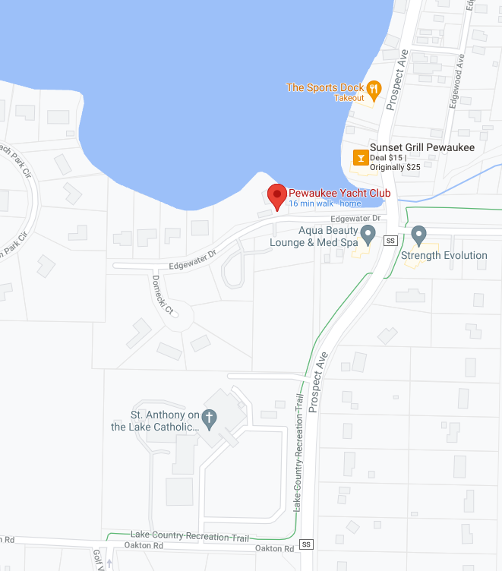

Addendum B – Racing Area

