
2025 Doug D’Alessandro
ne Day nly Opti Regatta
Sailing Instructions
Monday, Aug. 3rd 2026

1. RULES
1.1. The regatta will be governed by The Racing Rules of Sailing (RRS),
2025-2028 and the Optimist class rules
2. ELIGIBILITY
2.1. International Optimist Dinghies may enter by completing registration and
paying all entry fees. There will be no measurement requirements, except that
boats with the fiberglass tanks must have airbags inside the tanks.

3. NOTICES TO THE COMPETITORS
3.1. Notices to competitors will be posted on the official notice board at MYC.
4. CHANGES TO THE RACING INSTRUCTION
4.1. The Race Committee reserves the right to change the Sailing Instructions,
by posting the changes on the official notice board 0900. Oral changes to the SIs may be done on the water.
5.1. Monday Aug. 3, 2026
5.1.1. Registration: 8:00-9:00 am
5.1.2. Skipper's Meeting: 9:15 am
5.1.3. Harbor Start 9:30 am
5.1.4. Warning Signal 10:00 am first race of the day. Up to five (5) races may be sailed
5.1.5 Lunch served on land
5.1.6. No Warning Signal after 4:00 pm.
5.1.7. Raffle and Awards as soon as possible after return to shore
6. REGATTA FORMAT
6.1. Five races are scheduled
6.1.1. There will be one drop if five races are sailed. This modifies RRS A2.
6.1.2. One completed race shall be sufficient to establish a championship
6.2. There will be three fleets, the Gold and Silver Fleets will have one course, the Green Fleet
will have a separate race course.
6.3. Gold Fleet is for advanced sailors and will be divided into 3 divisions
6.3.1. White Fleet – 10 and under
6.3.2. Blue Fleet – 11 & 12 yrs
6.3.3. Red Fleet – 13 to 15
6.4. Silver Fleet is for intermediate sailors ages 12 and under and will be divided into 2 divisions
6.3.1. White Fleet – 10 and under
6.3.2. Blue Fleet – 11 & 12 yrs
6.5 Green Fleet is for beginner sailors (1st and 2nd year sailors)
6.6 The Gold and Silver Fleets will have separate sequential starts on the same course. Gold fleet will start first, followed shortly thereafter by the Silver Fleet. This pattern will occur for each Race, unless otherwise changed by the PRO.

7. COURSES
7.1. The Gold and Silver Fleet courses, including the approximate angles between legs, the order in which marks are to be passed, and the side on which each mark is to be left is shown in SI Addendum 1. The course length and exact configuration will be based on the sailing conditions.
7.1.2 Angle between marks may be changed up to 15 degrees in either direction to compensate for wind / current differences on that side of the course, without signals or change marks, provided the change is made before any boats begin that leg. This is added to RRS 33
7.2 The Green Fleet course will be a Port Triangle. See Addendum 2.
8. MARKS
8.1. The turning marks on the Gold/Silver course will be large inflatable Yellow marks or orange buoys
8.2. The change of course mark will be a large inflatable Yellow mark with black stripe.
8.3 The turning marks on the Green course will be orange or red hippity marks.
9. THE START
9.1. The starting sequence will be Three Minute Dinghy Start
9.2. The Race Committee will attempt to hail boats who are OCS, failure
of the boat to hear the Race Committee shall not be grounds for redress.
9.3. The starting line will be between a staff displaying a yellow(Gold fleet), gray(Silver fleet) or orange(Green fleet) flag on a race committee boat and an orange or white hippity mark or yellow inflatable conical pin.
9.4. A boat starting later than 5 minutes after her starting signal will be scored "Did Not Start"without hearing. This changes RRS A4 and A5.
10. THE FINISH
10.1. The finish line will be between a staff displaying a blue flag on the finish boat and a nearby orange hippity mark. The finish line for the Green fleet will be between a staff displaying an orange flag and the start/finish hippity mark.
10.2.1 The time limit for the first boat to sail the course and finish shall be sixty (60) minutes. If no boat sails the course and finishes within the time limit, the race for that fleet will be abandoned.
10.2.2 Boats failing to finish within 20 minutes after the first boat of her flight sails the course and finishes, will be scored “Time Limit Expired” (TLE) without a hearing. Boats scored TLE shall be scored last to finish plus 1. This changes RRS 35, A4 and A5 (Race Time Limit & Scores).
10.2.3 If a boat racing is delaying the start of another race, the race committee may terminate the race and notify the boat that she will be scored in the place she would have finished including TLE.

11. PENALTY SYSTEM
11.1. The penalty system described in rules 44.1 and 44.2 is changed so that only one-turn, including one tack and one jibe, is required. This changes rule 44.1.

12. PROTEST AND REQUEST FOR REDRESS
12.1. Any boat wishing to protest another boat must notify the protested boat of their intention
to do so by hailing 'Protest."
12.2. Protesting boat will notify the Race Committee of the protested boat's sail number as soon
as reasonably possible following the finish of that race.
12.3. Protest shall be written on forms available from the Race Committee, and delivered there
within 30 minutes after Protest time has been signaled to start.
12.4. The protest time limit will be the approximate time that the Race Committee boat
would have to return to the Club.
12.5. Notices will be posted no later than 30 minutes after the protest time limit to inform
competitors of hearings in which they are parties or named witnesses. Hearing will be
held in the protest room, located in the MYC Sailing Center office beginning at the time
posted.
13. SCORING
13.1. The Low-Point Scoring System, RRS Appendix A, will be used.
13.2. The regatta will consist of up to 5 races for each fleet.
13.3. One race will constitute a championship.
13.4. There will be 1 drop if at least 5 races are sailed. This modifies RRS A2.
14. SAFETY REGULATIONS
14.1. All participants must wear a USCG approved PFD while on the water and have
a working whistle.
14.2. Any competitor leaving the racing area shall attempt to notify the
Race Committee or, if that is impossible, immediately after arriving ashore.
Failure to notify the race committee in a timely manner may result in
disqualification for the day of racing.

15. SUPPORT BOATS
15.1. Team leaders, coaches, other support personnel and spectators shall stay outside
areas where boats are racing from the time of the preparatory signal for a race
until all boats have finished that race, or until the race committee
signals a postponement, general recall or abandonment
15.2. Coach/support and spectator boats shall follow the instructions of race committee and
race management boats. Coach/support boats are responsible for helping all boats in
distress.
16. PRIZES
16.1. Trophies will be awarded to the 1st thru 3rd overall in Gold Fleet and top 5 in Gold fleet for each fleet, Red, Blue, White and top 5 in Silver fleet for Blue and White fleets
16.2. All Green Fleet sailors will receive participant medals.
17. DISCLAIMER OF LIABILITY
17.1. Competitors participate in the regatta entirely at their own risk.
See rule 4, Decisions to Race.
The organizing authority will not accept any liability for damage
or personal injury or death sustained in conjunction with or prior to, during,
or after the regatta.

SI Addendum 1 -

Gold and Silver Fleet Course :

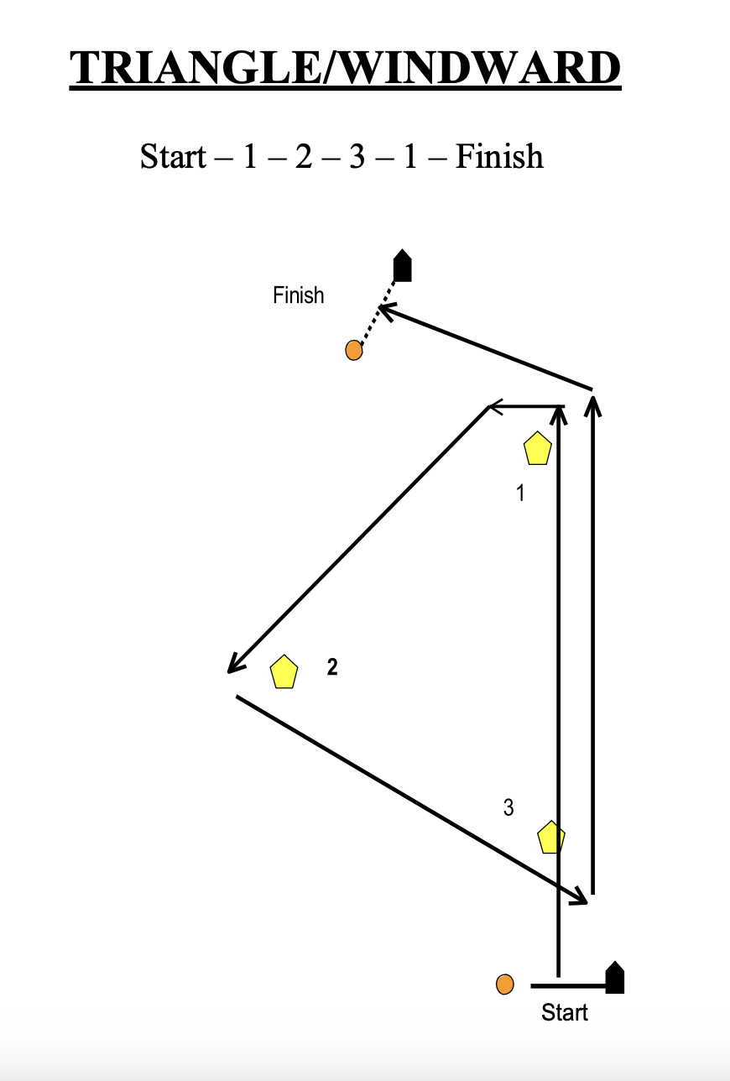

SI Addendum 2
Green Fleet Course

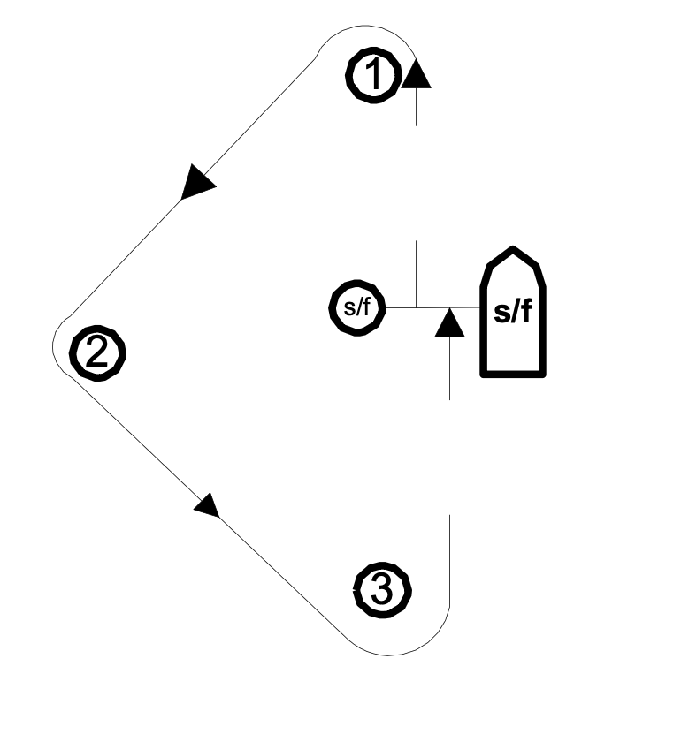

Note: Diagrams not to scale. Mark colors for illustrative purposes only.

