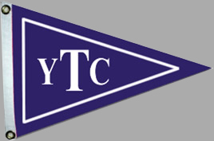

We are so excited to announce that the pool will officially open on Saturday, June 26th. We continue to follow the guidance from the RIDOH regarding COVID-19 protocols and will update the website as information is provided.

Swim lessons will begin on Tuesday, June 29th. The registration page can be found on the Swim page of the TYC website.

We can’t WAIT to see you!
Katie Bossolt and The TYC Pool Team

