NOTICE OF RACE
Newport Fall Spectacular 2026 – ECFS #4
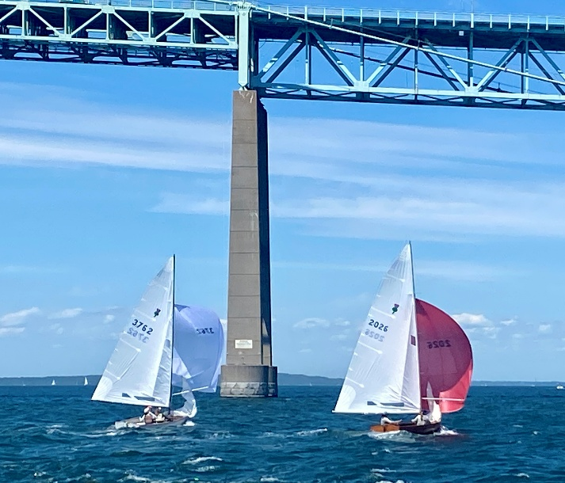
October 3 & 4, 2026
Hosted by
Newport Thistle Fleet 169
The International Yacht and Athletic Club (IYAC)
Sail Newport

Organizing Authority: Newport Thistle Fleet 169
Race Committee by International Yacht Athletic Club - I.Y.A.C.

RULES

  - The Regatta is governed by the rules as defined in the Racing Rules of Sailing.

SAILING INSTRUCTIONS

  - Will be posted on Club Spot by October 2, 2026 with hardcopies available at check in.

RADIO COMMUNICATION

  - The RC may transmit via VHF radio information concerning safety, OCS boats, and general information to assist in the management of the event. VHF channel to be announced at the skippers meeting. Except in an emergency, a boat that is racing shall not make or receive voice or data communication that is not available to all boats.

ELIGIBILITY AND ENTRY

Eligible boats may enter by completing online registration on Club Spot or at Sail Newport regatta venue Saturday October 3.

FEES

Registration Fee is $130 per boat.

ADVERTISING

Boats may be required to display advertising which will be supplied by the Organizing Authority.

SCHEDULE

Saturday October 3

930 hrs – Skippers Meeting

1100 hrs – Warning Signal Race 1. Additional races to follow.

TBA hrs – Après sailing social hosted by Laser Fleet 413.

Sunday October 4

900 hrs – Skippers Meeting- If needed

1030 hrs – Warning Signal. Additional races to follow.

1400 hrs – No race starts after.

TBA hrs – Awards in the boat park.

VENUE

8.1. Storage, hoist and ramp launching at Sail Newport, Ft. Adams, Newport RI

8.2 Races will be sailed on Narragansett Bay, in the vicinity of Newport Bridge. To be specified in SI's

8.3 Housing: No Camping allowed at Ft. Adams. Camping at private homes/farm is available. Local hotel information will be available. A limited amount of private housing will be available.

THE COURSES

Racing will be as shown in the Sailing Instructions.

A coastal “Navigators” race may be sailed.

- SCORING

The series scores will be the total for all races sailed, with no races excluded.

- BOAT LOANS

  - A limited number of Fleet 169 member boats will be available for loan. These will be available on a first come first served basis.

- FURTHER INFORMATION

For any questions or further information, please contact the event organizers:

Scott Pakenham, beaker27@aol.com Scott Vogel, slvogel87@gmail.com

