Emergency Safety Plan for Clear Lake Yacht Club
641-357-8001

For a medical emergency, dial 911

To meet first responders, proceed to the Clear Lake Yacht Club, 103 Main Ave, Clear Lake, IA

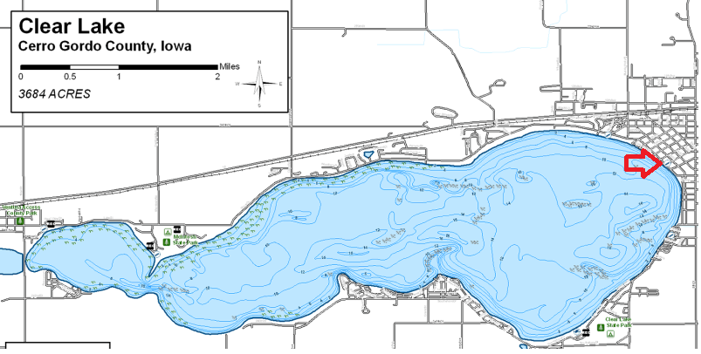

Nearest Emergency Room is MercyOne North Iowa, 1000 4th St SW, Mason City, IA

Be prepared to tell 9-1-1:
- Current location of injured person
- Description of boats (if requesting on-water help)
- You will bring the injured person to the CLYC building
- Age/gender/number of injured people
- Type of injury/situation
- Your name and call back number

In the meantime – Render assistance, monitor and administer first aid, call Event Safety Officer or PRO, send someone to meet emergency vehicles if needed.

Please do not speak to the press or anyone else other than the police or EMS about the incident.

First aid kits are available in the kitchen at the yacht club and on the Race Committee boats.

For Refuge, proceed to the nearest dock and tie up. In Iowa, all docks can be used for refuge.

