Halloween Regatta Spooks Championship Trophy

Emblematic of:  Autumn Snipe Class Championship and symbolizing good fellowship through competition  Donated by:  Snipe Fleet 330, Atlanta Yacht Club  Awarded to:  The winning skipper in the Spooks (top) division  Regatta Conditions:  Annually in October and/or November on the waters of Lake Allatoona, Georgia under the auspices of SCIRA and the donor and under such rules as promulgated by the donor and the Race Committee  Trophy Responsibility and Conditions:  Winner is responsible for care and safekeeping of trophy and return to sponsoring fleet prior to October 1 or upon demand by SCIRA  Revision of Deed of Gift:  By agreement between SCIRA Rules Committee and the donor | 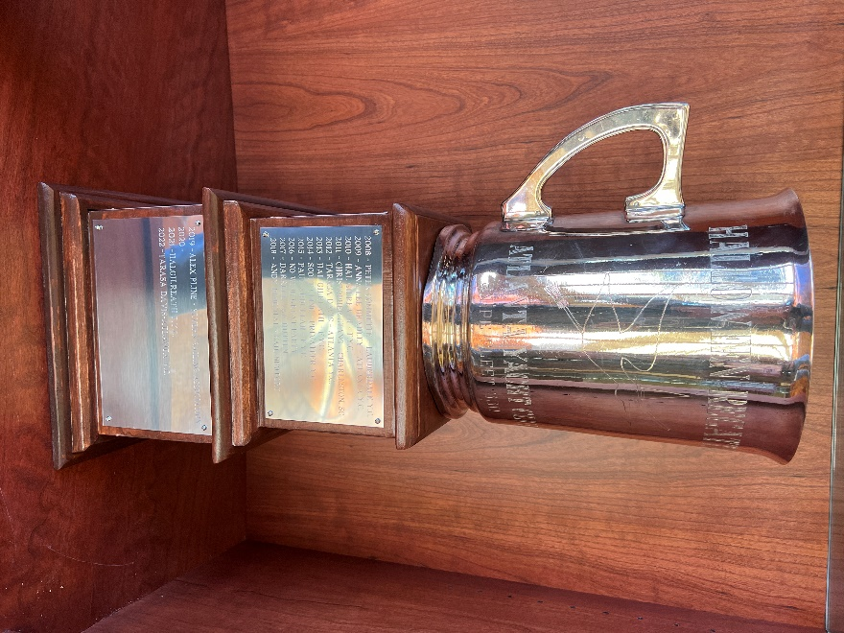

1953 Jules Kroeger, Rochester, NY
1954 Harold Gilreath, Wichita, Kansas
1956 Francis Seavy, Clearwater, Florida
1957 Francis Seavy, Clearwater, Florida
1958 Martha Hanson, Chautauqua, NY
1959 Woody Norwood, Atlanta, Geogia
1960 Francis Seavy, Clearwater, Florida
1961 Francis Seavy, Clearwater, Florida
1962 Dexter These, Grand Rapids, Michigan
1963 Howard Richards, Oakville, Ontario, Canada
1964 Francis Seavy, Clearwater, Florida
1965 Harold Gilreath, Wichita, Kansas
1966 Francis Seavy, Clearwater, Florida
1967 Francis Seavy, Clearwater, Florida
1968 Lloyd Cox, Chattanooga, Tennessee
1969 Lloyd Cox, Chattanooga, Tennessee
1970 John Call, Jr., Indianapolis, Indiana
1971 Pete Duvoisin, Chattanooga, Tennessee
1972 Dick Schmidt, Ann Arbor, Michigan
1973 Brad McFadden, Atlanta, Georgia
1974 Bill Buckles, Cleveland, Ohio
1975 Matt Gregory, Atlanta, Georgia
1976 Frank Levinson, Indianapolis, Indiana
1977 Gregg Fisher, Newport, Rhode Island
1978 Gregg Fisher, Newport, Rhode Island
1979 Matt Gregory, Chattanooga, Tennessee
1980 Steve Suddath, Pensacola, Florida
1981 Greg Fisher, Columbus, Ohio
1982 Jeff Evans, Springfield, Illinois
1983 Steve Suddath, Lake Lanier, Georgia
1984 Ed Adams, Narragansett Bay, Rhode Island
1985 Dave Pritchard, Lake Lanier, Georgia
1986 Greg Fisher, Columbus, Ohio
1987 Dave Pritchard, Lake Lanier, Georgia
1988 Shawn Burke, Lake Lanier, Georgia
1989 Steve Callison, Hoover, Ohio
1990 Peter Commette, Miami, Florida
1991 Shawn Burke, Lake Lanier, Georgia
1992 Henry Filter, Annapolis, Maryland
1993 Scott Nixon, Charleston, South Carolina
1994 Steve Burke, Lake Lanier, Georgia
1995 Brent McKenzie, Lake Lanier, Georgia
1996 Hal Gilreath, Lake Lanier, Georgia
1997 Hal Gilreath, Lake Lanier, Georgia
1998 John & Leslie Irvine, Atlanta, Georgia
1999 Shawn Burke, Lake Lanier, Georgia
2000 Pedro Lorson, Manhasset Bay, NY
2001 Hal Gilreath, Annapolis, MD
2002 Birger Jansen, Norway
2003 Steve Burke, Lake Lanier, Georgia
2004 Tarasa Davis, Atlanta, Georgia
2005 Bibi Juetz, Brazil
2006 Nicolas Granucci, Greensboro, NC
2007 Yuzo Morita, Japan
2008 Peter Commette, Ft. Lauderdale, Florida
2009 Anna Lee Bradley, Atlanta, Georgia
2010 Hal Gilreath, Jacksonville, Florida
2011 Christopher Stang, Charleston, South Carolina
2012 Tarasa Davis, Atlanta, Georgia
2013 Hal Gilreath, Jacksonville, Florida
2014 Scott Cline, Chattanooga, Tennessee
2015 Paul Abdullah, Jacksonville, Florida
2016 No Wind, Great Party!
2017 Darrell Van Hutten, Atlanta, Georgia
2018 Andy Pimental, Newport, Rhode Island
2019 Alex Pline, Annapolis, Maryland
2020 No wind, great party!
2021 Hal Gilreath, Jacksonville, Florida
2022 Tarasa Davis, Atlanta, GA

