Organizing Authority – Crystal Lake Yacht Club
3491 Pilgrim Hwy, Frankfort, MI 49635
Host – MC Sailing Association and Crystal Lake Yacht Cub
Wednesday August 26, 2026 - Saturday August 29, 2026

Sailing Instructions
Preamble – The notation ‘[NP]’ in a rule means that a boat may not protest or request redress under this rule. This changes Rules 60.4(a) and 61.3 as stated in the notice of race. The notation ‘[DP]’ in a rule means the penalty for breaking this rule may, at the discretion of the jury, be more or less than a single disqualification. This changes Rule 60.5(c).

Rules

The regatta will be governed by the rules as defined in the Racing Rules of Sailing (RRS)

US Sailing Prescriptions to Rule 63.1 shall not apply.

Rule 60.4(a)(2) is changed as follows: (2) if it alleges a breach of a rule of Part 2 or rule 31 and is from a boat that was not involved in, and did not see, the incident, or

Notices to Competitors

Notices to competitors will be posted on the official notice board located at https://clyc.net/regatta/NQGdRyjGTk.

Changes to the Sailing Instructions

Any change to the sailing instructions will be posted before 0900 or more than 90 minutes before a scheduled warning, whichever is earlier, on the day it will take effect, except that any change to the schedule of races will be posted by 2000 on the day before it will take effect.

Signals Made Ashore and Race Office

Signals made ashore will be made from a docked Race Committee vessel.

The race office is located at https://bit.ly/2025hearing.

When flag AP is displayed ashore, ‘1 minute’ is replaced with ‘not less than 45 minutes’ in Race Signals AP.

Schedule

Seven Races are scheduled.

No more than three races will be sailed in one day

Competitor’s Briefing: 0900 Thursday, August 27th at the clubhouse on channel 71.

The Warning Signal for Race 1 is scheduled for 1030 on Thursday, August 27, 2026 Subsequent races will follow. After going ashore, subsequent scheduled race warning times will be posted on the Official Notice Board at https://clyc.net/regatta/NQGdRyjGTk.

If three races have been completed, no warning signal will be made after 1200 on Saturday, August 29, 2026

If fewer than three races have been completed, no warning signal will be made after 1400 on Saturday, August 29, 2026.

Class Flag

The class flag will be the class insignia on a red, white and blue background.

Racing Area

The racing area will be in the navigable waters of Crystal Lake, primarily the west end of the lake.

Courses

No later than the warning signal, the race committee will designate the course by displaying one or two letters followed by a number, and it may also display the approximate compass bearing of the first leg.

The course diagrams show the courses, the order in which marks are to be passed, and the side on which each mark is to be left.

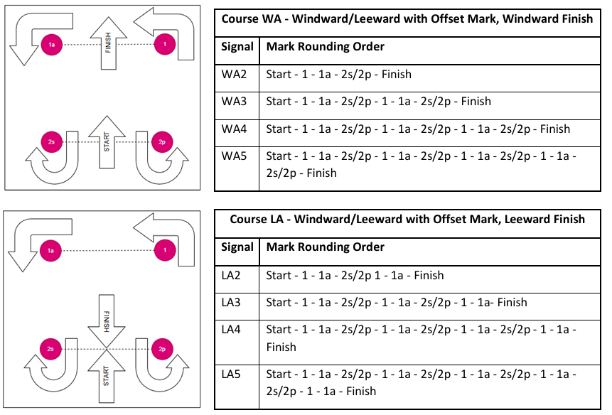

Marks

Marks will be red and yellow MarkSetBots.

Red MarkSetBots will be the windward mark and offset mark

Yellow MarkSetBots will be the leeward gate

Change marks will be the same as original marks unless Flag M is flown with a change of course signal, in which case an orange ball will replace the original marks.

The Start

The starting sequence will be RRS 26 (5 minute sequence), except that the flag and sound signals for the Class Flag and Flag P are replaced with the time on a boat’s ATDThis changes race signals and RRS 26.

Flag X is replaced with “OCS” being displayed with red lights on a boat’s ATD. When a boat returns to the pre-start side of the starting line or crosses an extension, “CLEARED” will show with green lights. A boat is responsible for complying with the definition of Start.

The starting line will be between two ATD’s mounted to MarkSetBots.

If Flag O or Second Substitute are displayed, the starting line will be

SI 10.1 and 10.2 shall not apply.

The starting line will be a line between the course side of two MarkSetBots.

RRS A4 is changed so that a boat that has not started within 4 minutes of her starting signal shall be scored DNS.

[NP] If an Approved Tracking Device “ATD” and Automated Race Management Systems (ARMS) for OCS detecting is not in use (Flag O or Second Substitute flying) then following the display of the Individual Recall signal, the RC will attempt to announce by VHF radio the sail numbers of all boats identified on the course side of the starting line at the start signal and boats that must comply with Rule 30.1. Such announcements are a courtesy. This changes RRS 62.1(a).

Change of the Next Leg of the Course

The race committee may change a leg of the course that begins at a rounding mark or at a gate by changing the position of the next mark (or the finishing line) and signaling all boats before any boat begins the leg. The next mark need not be in position at that time. Subsequent legs may be changed without further signaling to maintain the course configuration.

The RC may make minor adjustments (up to 10 degrees and .2NM in length) to the course before any boat begins the leg without signaling a course change. This changes RRS 33. A gate mark and/or offset may be moved without signal to be square to the race course after a course change.

The Finish

The finish line will be between ATD devices mounted to two MarkSetBots.

The Race Committee may display Flag A (with no sound) while boats are finishing to signal that there will be no more races that day. This changes Race Signals

The Race Committee may display Flag H (with no sound) while boats are finishing to signal that racing will continue after a break ashore. This changes Race Signals.

Time Limits

Mark 1 Time Limit: 30 Minutes. Time limit for the first boat to pass Mark 1.

Race Time Limit: 90 Minutes. Time limit for the first boat to sail the course and finish.

Finishing Window: 25 Minutes. Time limit for boats to finish after the first boat to sail the course and finish.

Boats failing to finish within the Finishing Window shall be scored TLE (Time Limit Expired), the position of the last boat that complies with RRS 28 to finish plus 2. This changes RRS 35, A5.2, and A10.

Hearing Requests

Hearing requests shall be delivered to the race office via https://bit.ly/2025hearing or as otherwise directed by the protest committee.

Hearing Time Limits
    - For protests about an incident observed in the racing area, 60 minutes after the last boat finishes the last race of the day or 60 minutes after the race committee signals no more racing today, whichever is later. This changes RRS 60.3(b)(1).
    - For other protests, 45 minutes after the relevant information is available to the protestor. This changes RRS 60.3(b)(2)
    - For redress requests, if based on an incident in the racing area, within the protest time limit or 60 minutes after the incident, whichever is later. This changes RRS 61.2(b)(2)

Notices will be posted no later than 30 minutes after the protest time limit or within 30 minutes of receipt, whichever is later to inform competitors of hearings in which they are parties and where the hearings will be held.

Hearings will be inside the club at CLYC, or another physical or virtual location deemed appropriate by the jury.

RRS 60.4(a) adds, "(4) if the protest is by a boat and the protest is based on a rule with the notation [NP]."

RRS 60.5(c) adds, "(5) the protest is based on a rule with the notation [DP] and the protest committee decides the penalty shall be more or less than a single disqualification."

RRS 61.3 adds, "or is a request by a boat and the protest is based on a rule with the notation [NP]."

Scoring [NP]

The Low Point System of RRS Appendix A will apply except as changed by SI 15.2, 15.3, and 15.4.

When fewer than 7 races are completed, a boat’s series score will be the total of her race scores. When 7 or more races are completed, a boat’s score will be the total of her scores excluding her worst score. This changes RRS A2.

RRS A10 adds the abbreviation definition: “TLE – Finishing Window Time Limit Expired. This changes RRS A10"

RRS A5.4 is added, “A boat that is scored TLE by the race Committee shall be scored points for the finishing place 2 more than the number of boats that sailed the course prior to the finishing window expiration."

Communication

The Competitor VHF Channel is 71. RC and safety channels will be announced at the competitors’ briefing.

The RC will use the Competitor VHF Channel to communicate about the racing, weather issues, safety concerns, and other actions where clarification may be helpful to the competitors.

[DP] Except in an emergency, a boat that is racing shall not receive voice or data communication that is not available to all boats or medically necessary.

[NP] [DP] A boat that retires shall inform the Race Committee as soon as practicable via the Competitor VHF Channel and/or by informing a Race Committee vessel verbally and/or by informing an event official ashore.

Prizes

Three races need to be completed before a National Championship is recognized and perpetual trophies awarded. One race constitutes a regatta for purposes of awarding keeper trophies. Awards will be based on her finishes in the overall fleet.

Keeper trophies are as follows:
- Per MCSA Trophy Policy

Equipment and Measurement

Each boat shall have its ATD location measured and entered during registration.

A boat or equipment may be inspected by an MCSA Official or a committee at any time for compliance with the class rules, notice of race and sailing instructions.

Assistance
  - RRS 41 adds: "(e) In the case of capsized boats or lost crew ("incident"), competitors may receive verbal and physical assistance in righting their boat or recovering lost crew and may thereafter continue to race; provided that after recovery, the boat is already at or returns to the approximate location of the incident."

ADDENDUM RS - Tracking Devices and Tracking Device Systems

Rules and Instructions for Using the Approved Tracking Device “ATD” and Automated Race Management Systems (ARMS) The approved ATD for this event includes Vakaros Atlas 2 and Vakaros Atlas Edge. The approved ARMS is Vakaros RaceSense.

Each boat shall have a working ATD configured for the ARMS at check-in. Boats without a configured ATD may have one provided by the OA, for applicable fees. After measurement and mounting, the ATD shall be mounted as measured during measurement at all times while racing.

The ARMS will be used by the Race Committee (RC) and the relevant information will be available to all boats. This changes RRS 41.

Boats shall update their ATD to the event firmware before racing. Boats shall additionally calibrate their device compass during check-in. Competitors shall take all reasonable measures to keep the ATD calibrated, updated, safe, and operational and promptly notify ARMS event staff on the water or ashore of any device issues. (Rule 56.3 states: When a rule requires a boat to be equipped with an Automatic Identification System transponder or any other tracking device, it shall not be turned off or its effectiveness intentionally reduced.)

RRS 26 is changed. The countdown to the start on the ATD from the ARMS will be the official time. Signal flags and sounds for starting races will only be used for information purposes.

[NP] Any hearing request by a boat alleging failure of an ATD or the ARMS system is invalid. Note: The RC, PC, or TC can request redress for failures of an ATD, ARMS System or Communications System. Competitors can make a scoring inquiry at https://bit.ly/2025hearing

If the RC vessel displays flag O (old school) with a sound signal before the warning signal of a race, ARMS will not be used during that race and all sailing instructions related to ARMS are not in force.

If the RC vessel displays flag R (reset) with repeated sound signals before the warning signal of a race, Competitors shall restart their ATD unit by switching it off, waiting 10 seconds and then switching it back on to reconnect to the ARMS network. Flag R will remain displayed for a minimum of 2 minutes and will be removed with the next warning signal.

If firmware updates to ATD devices are required between scheduled race days, notice will be sent to all boats to the email on record and/or phone on record via text and on the Official Notice Board.

Flag Reference [NP]
 | 
R Flag | O Flag

