SAILING INSTRUCTIONS
SNIPE CLASS INTERNATIONAL RACING ASSOCIATION

2026 Under 30 & US Junior National Championship
August 1-2, 2026
Mission Bay Yacht Club and Snipe Fleet 495
Mission Bay Yacht Club
Notation [NP]
The notation [NP] in a rule in the SI means that a breach of this rule shall not be grounds for a protest by a boat.
Notation [SP]
The notation [SP] in a rule in the SI means that for a breach of this rule a standard penalty will be applied.
Notation [DP]
The notation [DP] in a rule in the SI means that for a breach of this rule a discretional penalty will be applied.

1 RULES
1.1 The regatta will be governed by the rules as defined in The Racing Rules of Sailing.
1.2 The US National sailing prescriptions will apply.
1.3 The Snipe Class Rules of Conduct for Conducting National and International Championship will apply except for Rules 4.1, 5 and 5.1. Any conflict arising between the Deed of Gift and the SCIRA Rules of Conduct shall be resolved by the application of the Rules of Conduct.
1.4 In case of conflict between the Notice of Race and the Sailing Instructions the Sailing Instructions shall prevail.
2 NOTICES TO COMPETITORS
Notices to competitors will be posted on the official notice board located on the South wall of the Main Clubhouse.
3 CHANGES TO SAILING INSTRUCTIONS
3.1 Any change to the sailing instructions will be posted before 10:30 on the day it will take effect, except that any change to the schedule of races will be posted by 14:00 on the day before it will take effect.
3.2 Any change or amendment to the Sailing Instructions shall be approved by the SCIRA Representative.
4 SIGNALS MADE ASHORE
4.1 Signals made ashore will be displayed on the Flagpole on the south patio of the Main Clubhouse.
4.2 When the “AP” race signal is displayed ashore, ‘1 minute’ is replaced with ‘not less than 30 minutes’ in the race signal “AP”.
5 SCHEDULE OF RACES
5.1 Dates of racing:
Date | Time of  First Warning Signal
Sat Aug 1 | 1230
Sun Aug 2 | 1130
5.4 On the last day of racing no warning signal will be signalled after 1530.
5.5 There will be a competitor meeting at 1030 on Aug 1st.
6 CLASS FLAGS
The official Class Flag shall be the Snipe Class flag.
7 RACING AREA
The intended venue on Saturday will be the Pacific Ocean, approximately 0.5 NM NW of the Mission Bay Channel. The intended venue on Sunday will be Sail Bay.
8 THE COURSES
8.1 The diagrams below show the courses, including the approximate angles between legs, the order in which marks are to be passed. All course marks (except gates) shall be left to port.
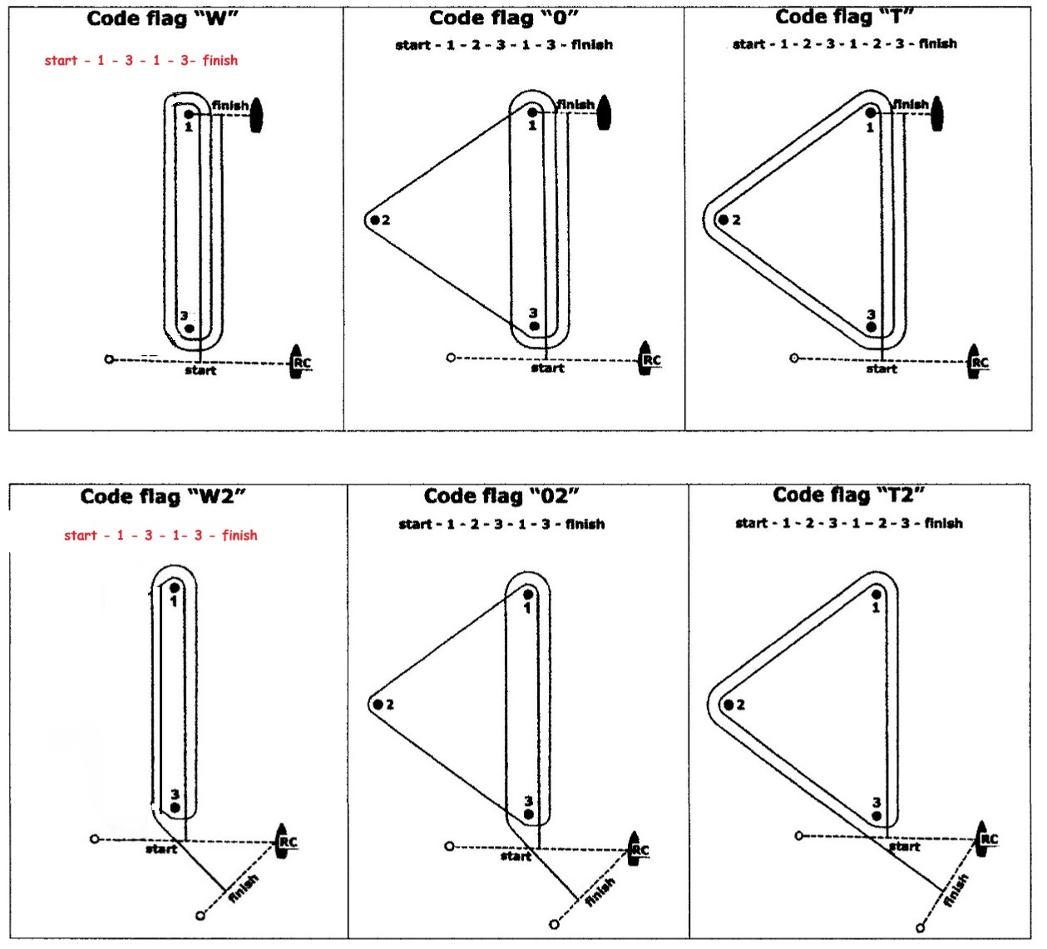

8.2 The course signal (code flag “W”, “T”, “O”, “W2”, “T2” or “O2”) shall be hoisted with one sound at least one minute before the warning signal. It will remain displayed for not less than five minutes after the start.
8.3 A sustained wind variation of 20 degrees or more during the first leg of a race shall result in the race to be abandoned. This changes RRS 32.1.
8.4 A sustained wind variation of 40 degrees or more during the first lap shall result in the race being abandoned. For this rule a lap means the rounding of mark 3 (or passing the gate 3s-3p) for the first time. This changes RRS 32.1.
8.5 The number of legs in a race may be reduced (RRS code flag S) but at least 2 (two) windward legs of the race shall be completed. This changes RRS 32.2.
9 MARKS
9.1 For ocean racing, marks 1, 2, 3, 3s and 3p will be Orange Tetrahedrons and mark 1bis will be a yellow tetrahedron. For bay racing marks will be orange balls.
9.2 New marks, as provided in instruction 13.1, will be yellow balls.
9.3 The port-end starting mark will be a staff with an orange flag
9.4 The finishing mark will be:
- mark 1 for “W”, “O”, and “T” courses;
- a staff with a blue flag displayed for “W2”, “O2”, and “T2” courses
9.5 A Race Committee vessel signalling a change of a leg of the course is a mark as provided in SI 11.2.
9.6 If one of the marks "gate 3s-3p" is not placed, or is not replaced as per RRS 34, the remaining mark shall be left to port. This changes the RRS 34.
10 THE START
10.1 The starting line will be between a staff displaying an orange flag on the Race Committee vessel at the starboard end and a staff displaying an orange flag on the pin end.
10.2 A boat starting later than 5 minutes after her starting signal will be scored Did Not Start without a hearing. This changes Appendices A4 and A5.
10.3 The races will be started in ordinance with RRS26 modified such that the warning signal will be given 3 minutes before the starting signal.

11 CHANGE OF THE NEXT LEG OF THE COURSE
11.1 To change the next leg of the course, the Race Committee will lay a new mark (or move the finishing line) and remove the original mark as soon as practicable. When in a subsequent change a new mark is replaced, it will be replaced by an original mark.
11.2 Except at a gate, boats shall pass between the race committee boat signalling the change of the next leg and the nearby mark, leaving the mark to port and the Race Committee vessel to starboard. This changes the RRS 28.
11.3 If Mark 1 will be changed in courses “W” or “W2”, Mark 1bis (offset) will no longer be a course mark.
12 THE FINISH
12.1 The finish line will be between a staff displaying a blue flag on a Race Committee vessel and the staff displaying a blue flag on the finishing buoy as provided in 9.4.
13 TIME LIMITS AND TARGET TIMES
13.1 The races will be managed to last 30 to 45 minutes for the first boat to finish. A different time (shorter or longer) used to complete the race will not be grounds for requesting redress.
13.2 The time limit for the first boat to complete the first lap is 30 minutes after the start. If the first boat fails to complete the first lap within 30 minutes the Race Committee shall abandon the race. For the purpose of this rule a lap means the rounding of Mark 3 (or passing the Gate 3s/3p) for the first time.
13.3 The time limit for the first boat to finish the race shall be 1 hour, 15 minutes. Any boat finishing more than 30 minutes after the first boat finishes or failing to finish within 2 hours from the start, whichever is shorter shall be scored Did Not Finish (DNF). This changes RRS 35, A4 and A5.

14 PROTESTS AND REQUESTS FOR REDRESS
14.1 Protest forms are available at the race office, located in the Main Clubhouse office. Protests and requests for redress or reopening shall be delivered there within the appropriate time limit.
14.2 The protest time limit is 60 minutes after the last boat has finished the last race of the day.
14.3 Notices will be posted no later than 30 minutes after the protest time limit to inform competitors of hearings in which they are parties or named as witnesses. Hearings will be held in the protest room, located in the Junior Clubhouse.
14.4 Notices of protests by the Race Committee, Technical Committee or Protest Committee will be posted to inform boats under RRS 61.1(b).
14.5 The penalty for breaking rules in the SI marked with [SP] may be applied at the discretion of the Race Committee, without a hearing, and shall be the 5% scoring penalty for nearest race completed by the infringing boat but not worse than the number of points corresponding to DSQ. This changes the RRS 63.1 and the App.A5.
14.6 The penalty for breaking rules in the SI marked with [DP] may be applied at the discretion of the Protest Committee.
14.7 Penalties for breaking Class Rules may be less than disqualification.
15 SCORING
15.1 3 races are required to be completed to constitute a series.
(a) When fewer than 6 races have been completed, a boat’s series score will be the total of her race scores.
(b) When 6 to 7 races have been completed, a boat’s series score will be the total of her race scores excluding her worst score.
16 A boat that retires from a race shall notify the Race Committee as soon as possible.
17 REPLACEMENT OF CREW OR EQUIPMENT
17.1 The same crew shall race in all races, except for reasons satisfactory to the Race Committee. Requests for a change of crew shall be submitted in writing to the Chairman. Once a crew has been excused, he/she may not return for the balance of the series.
17.2 The same skipper shall sail all races and can be replaced after the first race only, and then only if he/she is obviously incapacitated. If a skipper is replaced the first race shall be the race dropped, or scored DNC.
17.3 [DP] Substitution of damaged or lost equipment will not be allowed unless authorized by the Race Committee. Requests for substitution shall be made to the Race Committee at the first reasonable opportunity.
18 [NP] EQUIPMENT AND MEASUREMENT CHECKS
A boat or equipment may be inspected at any time for compliance with the Class Rules and Sailing Instructions. On the water, a boat can be instructed by a member of the Race Committee, or the Technical Committee, or the equipment inspector or measurer, to proceed immediately to a designated location for inspection.
19 [NP] [DP] SUPPORT BOATS
19.1 At the preparatory signal, coaches must be positioned at least 25 meters below the starting line or 25 meters outside of the starting line extensions. After the starting signal coaches may follow the fleet but not leave wakes nor interfere with competitors keeping a minimum of 50 meters from all competitors at all times.
19.2 Coaches shall not communicate with competitors after the warning signal for any race until after the competitors have finished the race.
19.3 Coaches shall register at the Junior Clubhouse Office and all support boats shall be identified with coaching flags.
20 [DP] RADIO COMMUNICATIONS
A boat that is racing shall not make voice or data transmissions and shall not receive voice or data communication that is not available to all boats, except in an emergency or when using equipment provided by the race committee.
21 [DP] DRONES
No drones are allowed closer than 500 m from racing areas from the Warning Signal for a race and after the last boat has finished the race. As a penalty for breaching this rule the protest committee may impose a discretionary penalty (DP) to all boats associated with the owner / operator of the drone. This does not apply to OA drones.
22 [NP] [DP] TRASH DISPOSAL
Trash may be placed aboard support and Committee Vessels.
23 PRIZES
Prizes shall be awarded as provided by NoR.

Doug Hart- Race Committee Chairman and SCIRA Representative

