

NOTICE OF RACE

2026 QUEENSLAND CHAMPIONSHIPS
November 14th – 15th 2026

Lake Cootharaba Sailing Club
Boreen Point, Queensland

with thanks to our Sponsor


A. Organising Authority and Location of Race
Lake Cootharaba Sailing Club (LCSC) 24 Boreen Parade, Boreen Point 4565 in conjunction with the Windsurfer Class Association of Australia and the Australian Windsurfing Association.

B. Rules
The regatta will be governed by the rules as defined in the Racing Rules of Sailing (RRS) (2021 – 2024) and the Windsurfer Class rules, except where these are changed by the Notice of Race (NOR) or by the Sailing Instructions (SIs).
If there is conflict between the NOR and the SIs, the SIs will take precedence.

C.1. - Rule 13. - While Tacking
Rule 13 is changed to:
After a board passes head to wind, she shall keep clear of other boards until her sail has filled.
During that time rules 10, 11 and 12 do not apply. If two boards are subject to this rule at the same time, the one on the other’s port side or the one astern shall keep clear.

C.2. - Rule 31. - Touching a Mark
Rule 31 is changed to:
While racing, a board shall not touch a starting mark before starting or a finishing mark after finishing. A board may touch a mark that begins, bounds or ends the leg of the course on which she is sailing.
C.3. - Rule 42. - Propulsion (Pumping)
As per Windsurfer Class rules, Rule 42 is changed to:
“A board shall be propelled only by the action of the wind on the sail, by the action of the water on the hull and by the unassisted actions of the competitor except when:
• Course racing and competitors are sailing to windward or on a close-hauled course, pumping (continuous and/or repetitive movement of the rig to induce wind-flow over the sail) is prohibited except for the first 30 seconds after the starting signal”
A member of the race committee or a designated observer who sees a competitor infringing these pumping restrictions may disqualify a competitor without a hearing.
Note: Pumping is unrestricted for slalom and marathon events (if held).

C.3. - Rule 44. - Penalties at the time of Incident
Rule 44 is changed to:
44.1 Taking a Penalty
A board may take a 360°-Turn Penalty when she may have broken one or more rules of Part 2 in an incident while racing. However, if the board caused injury or serious damage or, despite taking a penalty, gained a significant advantage in the race or series by her breach, her penalty shall be to retire.
44.2 360°-Turn Penalty
After getting well clear of other boards as soon after the incident as possible, a board takes a 360°-Turn Penalty by promptly making a 360° turn with no requirement for a tack or a gybe. When a board takes the penalty at or near the finishing line, her hull shall be completely on the course side of the line before she finishes.

D. Eligibility
Windsurfer Class boards including Windsurfer LT, Windsurfer One Design and Original Windsurfers using class supplied and approved equipment.
All competitors shall:
- Be paid up members of the Windsurfer Class Association of Australia (WCAA) for the 2026/27 membership year. You can check if you are a current member of the Windsurfer Class of Australia in the Member Directory:

https://aus-windsurfers-hosted.theclubspot.com/

You can join the WCAA as you register including taking the required insurance

- Have current Australian Windsurfing Association (AWA) 3rd party liability insurance either through WCAA membership with insurance or membership of Windsurfing Queensland (WQ) or another affiliated Australian Windsurfing Association (AWA) state or club-based organisation.

You can check the AWA register here:
http://www.windsurfing.org/files/info/AWA_Members.pdf

- Have a unique sail number, displayed in accordance with the Windsurfer Class Rules.
- In accordance with Australian Sailing Prescription to Rule 46, all competitors shall be a current member of a club aﬃliated with Australian Sailing and hold a valid Australian Sailing (AS) Number. If not, competitors can obtain a SailPass at registration (Sat morning 14th Nov 26) from LCSC issued for the duration of the event (2 days). Membership and temporary SailPasses provide competitors with foundational personal accident insurance. Host clubs require compliance with AS aﬃliation rules to maintain their own regatta liability cover. Paid up members of Australian Yacht & Sailing Clubs issue AS numbers to all sailing members. Use the Australian Sailing Number finder link here to ensure that your AS Number is current: www.sailing.org.au/member-finder/
- For competitors that require a SailPass, LCSC has agreed to a fee of $25 to cover the whole event (2 days). A SailPass can be purchased at Registration on the Saturday morning, or can be pre purchased at the following link:
https://www.revolutionise.com.au/lcsc/sailpass-2026-windsurfer-qld-state-titles

E. Entry Fee & Registration
Competitors will pay the prescribed entry fees as detailed below.
The event entry fee includes racing, trophies and event optional t-shirt (for an extra fee).
Entry fees that include T-Shirt orders need to be received by 11.59pm on November 1st, 2026. T-Shirts are $40 and can be ordered as part of the registration process on Clubspot. See link following Clubspot Registration Link:
https://theclubspot.com/register/regatta/D96wjwYYOU/class
Entry List Link:
https://theclubspot.com/regatta/D96wjwYYOU/#entry-list

Competitor Early Entry Fees ($AUD)
Category A - Cruiser | $80
Category B - Open | $100
Category C - Women | $100
Category D - Under 18 years (Youth) | $60

F. Registration
All competitors shall complete registration with the Organising Authority.
Registration will occur at LCSC between 0900 and 1000hrs on Saturday, November 14th 2026.
At or before Registration:
- All competitors will have to sign an Entry Form which includes the Entry Declaration and Disclaimer of Liability;
- All competitors will have their Third party liability (TPL) Insurance and AS number status checked;
- Competitors under 18 years of age must have an ‘Emergency Contact Form’ and ‘Media Consent Form’, completed by their parent/guardian;
- Male competitors will have their weight recorded;
- Proof of age of a competitor may be checked, if required by the Organising Authority

G. Schedule
Day/Date | Event | Time | Location
Saturday 14/11/2026 | Registration | 0900 –  1000hrs | LCSC
 | Briefing | 1030hrs
 | Racing Session 1 - Warning Signal not before | 1100hrs
 | Racing Session 2 | PM
 | Social – Apollonian Hotel Dinner BYO | ~1800hrs | Hotel
Sunday 15/11/2026 | Briefing | 0930hrs | LCSC
 | Freestyle Expression Session (conditions permitting) | 1000hrs
 | Racing Session 1 - Warning Signal not before | 1100hrs
 | Racing Session 2 - No warning signal after | 1330hrs
 | Presentation ASAP after last race |  | LCSC
 | Event Close
The event will be run on an ‘on call’ basis.
Saturday’s racing will be a conducted by LCSC on a dedicated race course for the QLD LT state championships.
Sunday’s racing will be as part of the usual LCSC racing program which will include several other sailing classes. A dedicated start sequence for Windsurfers will be provided as part of Sunday’s racing program.
Competitors are strongly advised not to leave the vicinity of LCSC during racing sessions as decisions to race may be made quickly based on changing conditions or racing requirements.
Decisions will be made by the Organising Authority based on safety, conditions and requirements to complete each of the competition disciplines.
Multiple briefings may be held, and changes may be made through verbal instructions or notices to competitors.

H. Competition Disciplines
Competition will be conducted in the discipline of Course Racing only.
Target competition program is a minimum five (5) and maximum of nine (9) Course Races.
An exhibition Freestyle event will be run if time permits. This would likely be done pre racing on Sunday morning in the (usually) lighter winds and take the form of a 30 min “expression session” with all freestylers sailing together in a dedicated area. Depending on numbers, the top 3 competitors may then have individual 3 minute sessions, from which the final, 1st, 2nd and 3rd places will be determined.

I. Competition Divisions
Racing will be conducted for Open and Cruiser divisions.
Cruiser division is for first time / returning racers, novices and more relaxed racers and will sail a shorter course / fewer laps.
For Open divisions, the following gender & weight divisions will be scored:
Women * (see below)
Men – Light / Medium / Heavy
Subject to numbers, further division(s) may be added at the discretion of the Organising Authority. The aim is to have a minimum of 10 competitors per weight division.
* Depending on numbers and/or individual preference, Women competitors may compete in the Men’s Open division. Women who do this will be required to be weighed and placed in the applicable Men’s weight division.
Weight Divisions will be allocated by the following method as per Class Rules:
Split Weights:
- Male competitors (plus any Women competing in the Men’s division) will be divided into categories of weight of equal numbers, including Youth.
- After the weighing procedure, in case the total number cannot be divided by the number of categories, the first category with one competitor more will be determined upon a random draw. In case two competitors have the same weight, the younger competitor will be considered the lighter.
- Before the start of the first race, a second weighing procedure may be called for the athletes close to the limits of the categories, in order to recheck the correct registered weight.
- Where there is a significant difference between cut-off weights and/or a number of competitor weights that are close to the limits between divisions, the Organising Authority may, in its absolute discretion, increase or decrease the number of competitors in a division to promote closer and fairer racing.
Weighing Procedure
  - Weighing of competitors will be conducted during the event registration period on the official scales provided by the Organising Authority.
  - Competitors will weigh in T-shirt and shorts only (no footwear) – with all pockets emptied.
  - Competitors may be re-weighed at any time during an event at the discretion of the Organising Authority.
  - If subsequent weighing of a competitor indicates a variation of more than 2 kilograms from the original weight that would cause a competitor to change weight division the Organising Authority will assess the circumstances and have the option to change the competitors’ division.

J. Equipment
It is the responsibility of each competitor to ensure that their equipment conforms to the current Class Rules.
Check the class website for various equipment and membership details, link below.
https://www.windsurfer-class-aus.com/
Equipment inspection may be undertaken at any time during the Event by the Organising Authority to ensure compliance with Class Rules.
Those in Cruiser division may use:
- sails of less than 5.7 metres of any make or model including the Class 4.5 trainer sail
- masts and booms of any make and model

K. Sailing Instructions
The Sailing Instructions (SIs) including course format and racing procedure will be available online no-later than 3 days prior to the event.
Further instructions may be provided verbally at Briefings and also by Notices to Competitors.
The SIs and Notices to Competitors will be available on the Official Notice Board at LCSC.

L. Scoring
Scoring will be conducted by division.
If multiple divisions are raced in a fleet, the across the line results will be rescored into divisional results.
For example, if Category A and Category B raced in the same fleet and the first Category B board finishes third across the line, it is rescored to 1st for the Category B division.
The Low Point System - RRS Appendix A Scoring will apply.
Three (3) course races are required to be completed to constitute a series.
When fewer than 5 course races have been completed a board’s series course racing score will be the total of her divisional race scores.
When from 5 to 8 course races have been completed, a board's series course racing score will be the total of her divisional race scores excluding her worst score ("one drop").
When 9 or more course races have been completed, a board's series course racing score will be the total of her divisional race scores excluding her two worst scores ("two drops").

M. Buoyancy
All competitors shall wear whilst racing personal flotation devices which are in good condition and are in accordance with the specifications approved by the National Authority at or above the minimum level required (ie L50/ level 50) or as approved by the Organising Authority (changes rules 27.1 and 40.1.) Attention is drawn to rule 1.2.

N. Trophies, Prizes and T-shirts
Prizes will be awarded at the discretion of the Windsurfer Class Association.
A T-Shirt will be included as an optional part of your entry fee for $40, there is an option to purchase this in various sizes as part of the registration checkout process in Clubspot. Additional t-shirts can be purchased for $40 during the event. Please ensure you register at least 2 weeks before the event to guarantee your t-shirt size.

O. Responsibility
Attention is drawn to Fundamental Rule 3 - Decision to Race, which states "The responsibility for a board's decision to participate in a race or to continue racing is hers alone".
It is the competitor’s sole decision to enter this event and to start and or to continue to compete. By way of entering, competitors acknowledge and agree that participation in this event can be dangerous and accept that their participation is at their exclusive risk in every respect. In addition, by way of entering competitors shall hold harmless the organising authority, its officers, members, servants and agents and all other competitors in respect of all liability for injury to their person and or loss or damage to their property howsoever arising from their participation or intended participation in this event and acknowledge and accept that the organising authority, its officers, members, servants, agents and other competitors accept no responsibility in respect to loss of life, personal injury or loss or damage to property which may be sustained by reason of a competitor’s participation or intended participation in this event or arising for whatever reason in connection with this event.
Competitors will sign a disclaimer of liability at registration.

P. Advertising
Competitors may be obliged by the Organising Authority to display advertising of sponsors on sails and/or other equipment and/or on their persons in accordance with World Sailing Regulation 20.

Q. Media Rights
Competitors give full rights and permission to the Organising Authority and / or Windsurfer Class Association of Australia for use and broadcasting of photographs or videos of persons or boards competing in the event including, but not limited to, spots on television, online mediums and social media and can be used for editorial purpose, promotion or printed information.
Competitors under 18 years of age may opt out when completing the disclaimer of liability at registration.

R. Additional Information
Updates will be provided via any of the following methods – email, social media or website.
Windsurfer Class website
Queensland Windsurfer Class Facebook

For specific questions about LCSC and local issues:
Todd McVey: todd@metromoney.com.au

For general event information, entry queries, membership, t-shirts and class matters: Matt Williams mott69@gmail.com

Appendix 1 – Regatta Site and Racing Area
Lake Cootharaba Sailing Club – 24 Boreen Parade, Boreen Point 4565 Lake Cootharaba is a large lake located north of Noosa, QLD.
The racing area will be the waters off Boreen Point, adjacent to Lake Cootharaba Sailing Club.
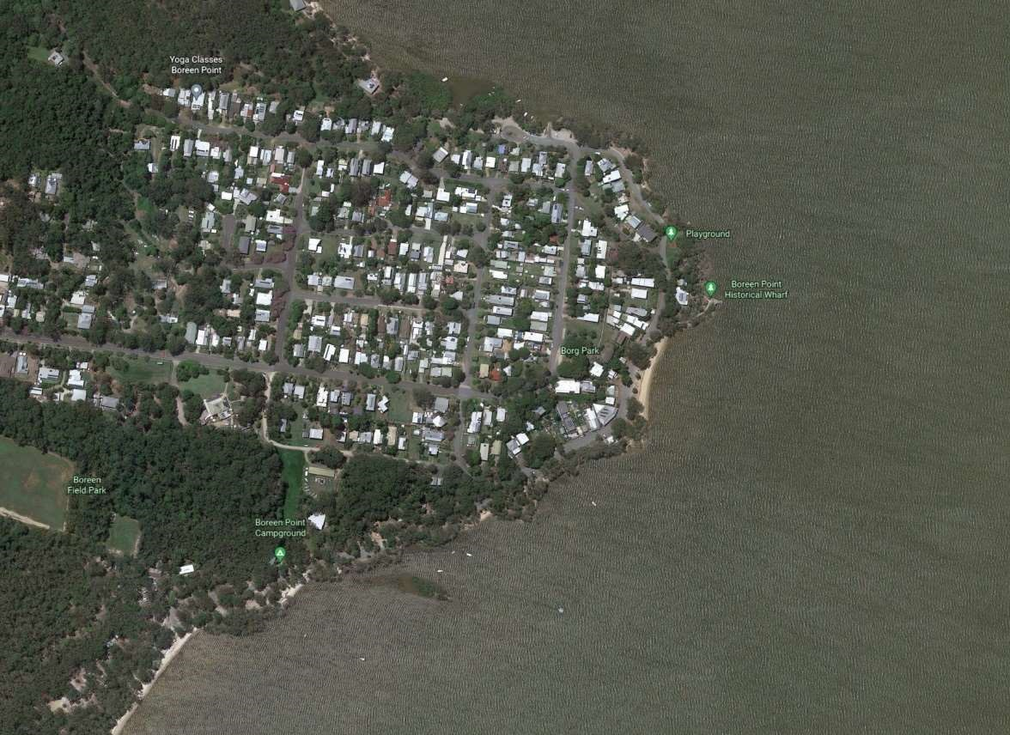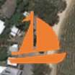

LCS

Weather
Sailing at Lake Cootharaba provides a challenging variety of potential conditions.
Land effects may come into play.
The prevailing sea breezes are usually from the northeast and southeast directions.
If the wind does pick up, the waves can get steep quickly as it is such a shallow lake..
Sea breezes at this time of year are usually consistent and peak at 12-15 knots around 2pm.

Appendix 2 – Additional Information
Secure board storage may be available to a limited number of competitors if required.

