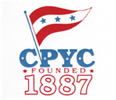

THISTLE CLASS ASSOCIATION (TCA)
ATLANTIC COAST & NEW ENGLAND DISTRICT CHAMPIONSHIPS
July 11-12, 2026
CEDAR POINT YACHT CLUB (CPYC)
Bluff Point, Westport, CT

SAILING INSTRUCTIONS (SIs)

Amendment 1

SI 21 RADIO COMMUNICATION is changed to:

21.1 Competitors may receive VHF radio transmissions from the Race Committee on channel 79 concerning
safety, notice of on course side (OCS) boats and general information to assist in the management of the event.

This changes the VHF channel from 72 to 79

Posted: July10, 2026 at 1600hrs

