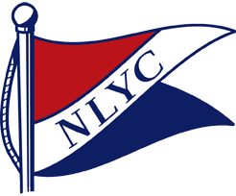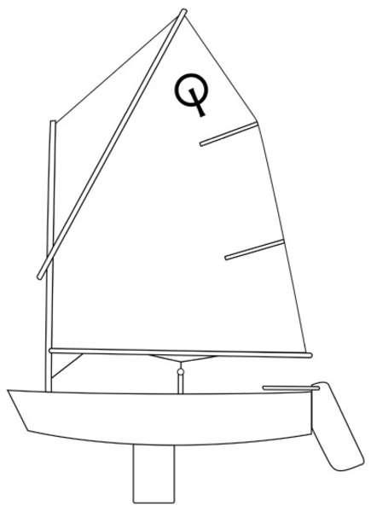
Notice of Race
2026 LOPN OPTI REGATTA
Tuesday - July 21st, 2026
Hosted By:
NAGAWICKA LAKE YACHT CLUB
Nagawicka Lake Yacht Club, 1131 Mariner Dr. Hartland, WI

This Regatta is open to all OPTI Sailors from La Belle Yacht Club, Okauchee Lake Yacht Club, Pewaukee Yacht Club, and Nagawicka Lake Yacht Club.

Please Note: Each Boat Registered must be represented and supervised by an adult on the regatta grounds/water during the entire event. Spectator boats will be provided.

Tuesday July 21, 2026

7:00 to 9:00 a.m. – Register, drop off, and check in

9:00 a.m. - Mandatory Skippers Meeting

10:00 a.m. - Scheduled First Race Warning. There will be Junior and Senior Fleets sailed.
(Juniors – 9 and Under Seniors – Ages 10-14 As of 01/01/26)
Weather, Wind and Time permitting, we will plan for 4 Races in each Fleet.

TROPHIES - Awarded to Top 5 Skippers in each Fleet

CONTACT – Regatta Chairs: Jana Petersen-Pingel nagawickasailingschool@gmail.com
Stacy Michels hajinian@gmail.com

REGISTRATION - Register online at sailnlyc.com
Includes regatta shirt, lunch for registered sailors
$65 per Boat ($80 if two in one boat) if registered before Sunday, July 5th.
$75 ($90) If Registering after July 5th.
Day of registration allowed, but no swag guaranteed.
Pre-orderded extra shirt $20, extra lunch $10

