
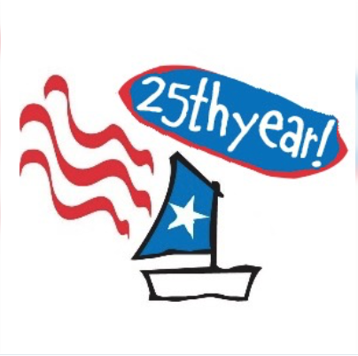

Sailing Instructions
RED, WHITE, AND BLUE CHIP REGATTA
25th ANNUAL OPTIMIST INVITATIONAL CHAMPIONSHIP AUGUST 2-4, 2026
LA BELLE YACHT CLUB, Organizing Authority

Race Venue is located at: N59W38465 Kohl Lane, Oconomowoc, WI 53066

- RULES
1.1 The event will be governed by the rules as defined in The Racing Rules of Sailing (the “RRS”).

2. NOTICES TO COMPETITORS
2.1 Notices to competitors will be posted on the official notice board and online portal.

3. CHANGES TO SAILING INSTRUCTIONS
3.1 Any change to the sailing instructions will be posted before 0800 on the day it will take effect. Any change to the schedule of races will be posted by 2000 on the day before it will take effect.

4. SIGNALS MADE ASHORE
4.1 Signals made ashore will be displayed from the Signal Boat docked near the Race Venue.
4.2 If a postponement is made ashore, the warning signal for the next race will be made not less than 30 minutes after AP is lowered.

5. RACE SCHEDULE, Scoring
5.1 The warning for the first race on Monday will be at 1000. Subsequent races as
announced by the race committee.
5.2. The Warning Signal for Tuesday's first race will be posted to the Official Notice
Board no later than 1800 Monday evening.
5.3. No race warning shall be made after 1400 on Tuesday.
5.4. Six races are scheduled. All races will be scored. This changes RRS A2.1.
5.5 One race will constitute a regatta.

1

6. CLASS FLAG
6.1 The class flag shall be a white flag with a blue Optimist logo.

7. RACING AREA
7.1 The racing area shall be the larger western or smaller eastern basin of Lac La Belle, depending upon wind direction and velocity.

8. COURSES AND MARKS
8.1 There will be one course area for all fleets. No later than the warning signal, the race committee will designate the course by displaying the course abbreviation and number on a course board on the race committee boat.
8.2. Courses are described in Appendix A of these Sailing Instructions.
8.3. The windward and offset mark turning marks will be orange balls. The gates will be orange balls. The finish mark will be of a different color.
8.4. If a gate mark, or either the windward mark or the offset mark is missing, boats shall round the remaining mark on that leg of the course to port.

9. THE START
9.1. Races will be started using Appendix U- Audible Signal Racing System [3-minute sequence], and all fleets will start together.
9.2 The starting line will be from a staff displaying an orange flag at the starboard end
of the line and either:
9.2.1. the staff of an orange flag on a boat at the port end of the line, or
9.2.2. the course side of an orange mark.
9.3. A boat that does not start within 5 minutes of her signal will be scored DNS for that
race without a hearing. This changes RRS A5.

10. RECALLS
10.1 The Race Committee will attempt to announce by hail the sail number of all boats identified on the course side of the starting line after the starting signal is removed. Flag X will not be displayed. Such an announcement is a courtesy, and failure of the Race Committee to make the announcement, or of boats to understand it, or the order of such hails, shall not be grounds for granting redress. This changes RRS 61.1.

11. THE FINISH
11.1. The finishing line will be displayed between a orange flag on a Race Committee boat and the course side of a non-orange finishing mark.
11.2. Flag "A" with no sound while boats are finishing means "no more racing today."
11.3. Flag "H" with no sound while boats are finishing means "await further instructions
ashore.”

2
12. PENALTIES
12.1. Penalties for breaking Rule 42: Appendix P will apply.
12.2. Penalties for breaking rules of Part 2: a one-turn penalty shall apply. This changes
RRS 44.1.

13. PROTESTS AND REQUESTS FOR REDRESS
13.1. Protests shall be on written forms available at Regatta Headquarters and delivered there within the Protest Time. Protest Time will end 45 minutes after the signal boat docks after racing is completed for the day, or the race committee signals no more racing today, whichever is later.
13.2 The Prescriptions to RRS 63.1 shall not apply.

14. TIME LIMITS
14.1 The target time for each race shall be 30 minutes. Failure of the Race Committee
to meet the target time shall not be grounds for redress.
14.2 The time limit for the first boat to reach Mark 1 is 30 minutes. If no boat has passed Mark 1 within the Mark 1 time limit, the race shall be abandoned.
14.3 The time limit for the first boat to finish shall be 60 minutes.
14.4 The window for finishing shall be 20 minutes after the first boat finishes. Boats not
meeting the finishing window time will be scored TLE, which is the mathematic mean
(rounded to the nearest integer) of the places not finished amongst boats that started
that race. This changes RRS A5.1, A5.2, & A10.

15. Inquiries to the Race Committee
15.1 Any questions concerning the Notice of Race, Sailing Instructions, Actions taken by the Race Committee, Scoring, or other issues shall be submitted in writing, with the replies posted on the Official Notice Board.

16. [DP] Code of Conduct
16.1 The Code of Conduct attached hereto as Appendix B is binding upon all competitors, parents, coaches, and support persons.

3

APPENDIX A
COURSE DIAGRAM

LA

LA

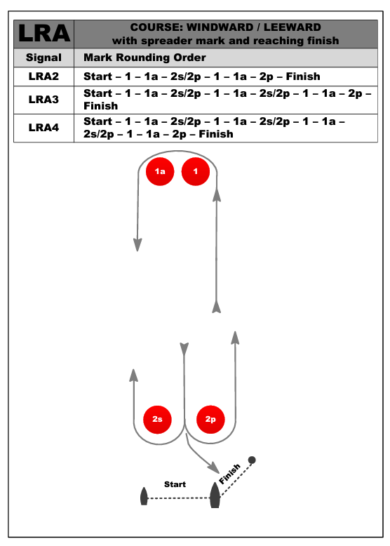

LA 2

LA 4

LA 3

4

Appendix B
CODE OF CONDUCT
1 Purpose
This Code of Conduct applies to all competitors, coaches, parents, guardians, and support persons participating in or attending the regatta. Its purpose is to promote sportsmanship and respect for others on and off the water.
2 Sportsmanship
(a) All competitors shall compete in compliance with the Racing Rules of Sailing and in the spirit of fair play.
(b) Unsportsmanlike conduct, which may include abusive, foul, or disrespectful language or arguing with race officials, coaches, or other competitors, is prohibited.
(c) Coaches and parents shall encourage and model good sportsmanship at all times.
3 Respect for Others
(a) All participants, coaches, parents, and guardians shall treat competitors, race officials, volunteers, and event staff with courtesy, dignity, and respect.
(b) Verbal, physical, or emotional abuse, bullying, harassment, or discriminatory behavior will not be tolerated.
4 Behavioral Standards
(a) Competitors shall follow instructions from race officials, event staff, and coaches promptly.
(b) Coaches, parents, and guardians shall not interfere with race management.
(c) Coaches shall provide positive, constructive instruction and shall refrain from negative or abusive behavior.
5 Discipline [DP]
(a) Failure to comply with this Code may result in disciplinary action by the organizing authority or protest committee.
(b) Disciplinary actions may include verbal warnings, written warnings, disqualification from a race or races, removal from the event, or exclusion from future events.
(c) Serious misconduct may result in immediate removal from the venue or regatta without refund of entry fees.
6 Agreement to Comply
By entering this event, competitors, coaches, and parents agree to abide by this Code of Conduct and accept any consequences for violations as determined by the organizing authority or protest committee.

5

