Lake Beulah Yacht Club, East Troy,
N9220 East Shore Road, East Troy, WI
WI 43rd Dorn Memorial Regatta Friday, September 11, 2026 to
Sunday, September 13, 2026

Information
- Registration and meal purchases may be completed during the scheduled registration times or by using the Clubspot Registration site.
- The entry fee is $105; late $125 after 9/1/26
- Regatta Headquarters is Lake Beulah Yacht Club, N9220 East Shore Rd, East Troy, WI 53120.
- This event will be a wet/dry sail regatta. If you plan to wet sail overnight, bring adequate anchor, rode, and a white float with a blue stripe. The mooring area is approximately 10’ deep and muddy. Bring your lifting bridle for crane launch
- Breakfast, Lunch, and Dinner is included for one competitor per boat. Additional tickets are available
-Lunch $15
-Saturday Dinner $25

Schedule:
Friday, September 11
  - Registration open 1800 – 2100
  - LBYC Bar open for business 1800-2100
Saturday, September 14
  - Registration 0730-0930
  - Coffee and Rolls served – 0730-0930
  - Competitor’s Briefing 0930
  - Race 1 Scheduled Warning 1030
  - Lunch on Shore - TBD
  - Cocktails - 1800
  - Steak Dinner - 1830
Sunday, September 15
  - Coffee and Rolls served – 0800-0900
  - Racing Continues – Estimated 1000
  - Lunch and Awards – After racing
  - Trophy Presentation estimated 1230 in the LBYC dining room

Lake Beulah Yacht Club, East Troy, WI 43rd Dorn Memorial Regatta Friday, September 11, 2026 to
Sunday, September 13, 2026

Notice of Race & Sailing Instructions
The notation ‘[DP]’ in the NOR & SIs means that the penalty for a breach of that rule may, at the discretion of the protest committee, be less than disqualification. The notation ‘[NP]’ in the NOR means that a breach of this rule may not be protested by a boat.
- Rules 3
- Advertising 4
- Eligibility and Entry 4
- Fees 4
- Insurance 4
- Risk Statement 5
- Notices to Competitors 5
- Changes to NOR/Sailing Instructions 5
- Signals Made Ashore 5
- Schedule 5
- Class Flags 5
- Venue & Racing Area 5
- The Courses 6
- Marks 6
- The Start 6
- Change of the Next Leg of the Course 7
- The Finish 7
- Penalty System 7
- Time Limits 7
- Protests and Requests for Redress 7
- Scoring 8
- Radio Communication 8
- Measurement 8
- [NP]Prizes 8
- Disclaimer of Liability 8
- Further Information 8

Rules
  - The regatta will be governed by the rules as defined in The Racing Rules of Sailing
  - Appendix T - Arbitration will apply.
    - Rule T1(b) is changed to “A Post-Race Penalty is a 30% Scoring Penalty or 50% of the places between the boat’s finishing position and the number of entries, whichever is less, calculated as stated in rule 44.3(c). However, Rule 44.1(a) applies.
  - Racing rule(s) 29.1, 30.1, 30.3, 30.4, 35, 41, 44.1, 44.2, 61.1, 61.3, 62.2, A4.2, A4.11, &
Race Signal AP will be changed as follows (changed language in bold or strikethrough):
    - RRS 29.1 inserts, “… promptly display flag X with one sound. Additionally, as soon as practicable, the Race Committee will hail via the competitor VHF Channel the list of boats identified that shall comply with RRS 30.1 and/or RRS 30.2. The flag shall be…”
    - RRS 30.1 is changed to. “If flag I has been displayed, and any part of a boat’s hull, crew, or equipment is on the course side of the starting line or one of its extensions during the last minute before the starting signal, she shall sail across an extension or around a mid- line boat in place under NOR/SI 15.2.3 or 15.2.4, leaving it to port, before starting.

RRS 30.3 & 30.4 are appended with, “Additionally, the Race Committee will hail via the competitor VHF channel the list of boats identified as breaking rule 30.3. Special attention is called to World Sailing Case 65.”
    - Rule 33 adds, (d) Minor changes will not be signaled.
    - Boats failing to finish within the Finishing Window shall be scored TLE (Time Limit Expired), the position of the last boat that complies with RRS 28 to finish plus 2. This changes RRS 35, A4.2, and A11.

RRS 41 adds, “41 (e) A crew member who is overboard or crew members whose boat is capsized are considered “in danger” and may continue racing without penalty after receiving outside assistance.”

RRS 44.2 is changed to, “(a) If a boat may have broken a rule of Part 2 or when she may have broken Rule 31 with the Zone of mark 1 or between marks 1 and 1a in course diagrams, a boat takes a One-Turn penalty by getting well clear of other boats, no later than promptly after rounding mark 1a, and making the required turn in the same direction, including one tack and one gybe.
    - (b) When a boat may have broken a rule of Part 2 or broken Rule 31 and is not within the Zone of mark 1 or between marks 1 and 1a in course diagrams, after getting well clear of other boats as soon after the incident as possible, a boat takes one turn by promptly making the turn in the same direction, including one tack and one gybe. When a boat takes a penalty at or near the finish line, she shall sail completely to the course side of the line before finishing.”
    - RRS 61.1 adds, “61.1 (e) Boats intending to file a protest against another boat or seek redress are requested to inform the race committee as soon as practicable after finishing.”
    - RRS 61.3 is referenced in these Sailing Instructions to make the time limit 60 minutes after the last boat in the race finishes the last race before the conclusion of racing for the day or a break ashore, or after the signal is made for a break ashore or no more

racing today, whichever is later.
    - RRS 62.2 is changed to, “A request shall be in writing and identify the reason for making it. If the request is based on an incident in the racing area, it shall be delivered to the race office within the protest time limit. Other requests shall be delivered as soon as reasonably possible after learning of the reasons for making the request. The protest committee shall extend the time if there is good reason to do so. No red flag is required. On the last day of racing a request for redress based on a protest committee decision shall be delivered no later than 30 minutes after the decision was posted.
    - RRS A4.2 is changed to, “A boat that did not start within 4 minutes of the starting signal, did not finish, retired or was disqualified shall be scored the points for the finishing place one more than the number of boats entered in the series. A boat that is penalized under rule 30.2 or that takes a penalty under rule 44.3(a) shall be scored points as provided in rule 44.3(c).
    - When flag AP is displayed ashore, ‘1 minute’ is replaced with ‘not less than 45 minutes’ in the race signal AP

Advertising
  - [DP] Boats may be required to display advertising chosen and supplied by the organizing authority. If this rule is broken, World Sailing Regulation 20.9.2 applies.

Eligibility and Entry
  - The regatta is open to boats of the MC Scow class.
  - As a condition of entry, competitors give Lake Beulah Yacht Club, its successors or assigns, absolute right and permission to reproduce video footage or photographs of themselves or their boat generated during a Lake Beulah Yacht Club event to be published in any of its printed and online publications (such as newsletters, annual reports, websites, social media posts, and blog posts) and in any media for press, editorial, and advertising purposes.

Fees
  - Required fee is $105 prior to 9/1/26; $125 thereafter

Insurance
  - [NP][DP] Each ‘person in charge’ (see RRS 46) shall secure adequate valid third-party liability insurance.
  - The Organizing Authority is not responsible for verifying the status or validity of insurance.

Risk Statement
Competitors and support persons participate in the series entirely at their own risk and they are reminded of the provisions of RRS 4, Decision to Race. Sailing is by its nature an unpredictable sport and therefore involves an element of risk. By taking part in the event, each competitor agrees and acknowledges that:
  - They are aware of the inherent element of risk involved in the sport and accept responsibility for the exposure of themselves, their crew and their boat to such inherent risk whilst taking part in the event.
  - They are responsible for the safety of themselves, their crew, their boat and their other property whether afloat or ashore.
  - They accept responsibility for any injury, damage or loss to the extent caused by their own actions or omissions.
  - By participating in any race, they are satisfied that their boat is in good order, equipped to sail in the event and they are fit to participate.

Notices to Competitors
Notices to competitors will be posted on the official notice board located on the windows of the Lake Beulah Yacht Club.

Changes to NOR/Sailing Instructions
Any change to the sailing instructions will be posted before 0900 or 90 minutes before a scheduled warning signal, whichever is earlier, on the day it will take effect, except that any change to the schedule of races will be posted by 2000 on the day before it will take effect.

Signals Made Ashore
  - Signals made ashore will be displayed on the Lake Beulah Yacht Club flagpole.
  - Race signal AP is changes as stated in NOR/SI 1.3.14.

Schedule
  - Regatta Registration
Friday, September 11, 2026 Saturday, September 12, 2026
From 1800 to 2100 From 0730 to 0930
  - The competitor’s briefing will be in the main dining room of the Lake Beulah Yacht Club and via VHF Channel 72 at 0930 on Saturday, September 12, 2026
  - Dates of Racing Saturday, September12, 2025 through Sunday, September 13, 2026
  - Number of Races: Up to 5 races are scheduled. No more than 3 races will be sailed on Saturday. No more than 2 races will be sailed on Sunday.
  - The scheduled time of the warning for the first race is 1030 on Saturday, September 12, 2026.
  - On the last scheduled day of racing, no warning signal will be made after 1200. The class flag will an MC class logo on a white background
- Class Flags
- Venue & Racing Area

  - The regatta harbor will be the bay to the south of Lake Beulah Yacht Club.
  - The racing area will be the navigable waters of Lake Beulah.

The Courses
  - No later than the warning signal, the race committee will designate the course by displaying one or two letters followed by a number.
  - The course diagrams show the courses, the order in which marks are to be passed, and the side on which each mark is to be left.
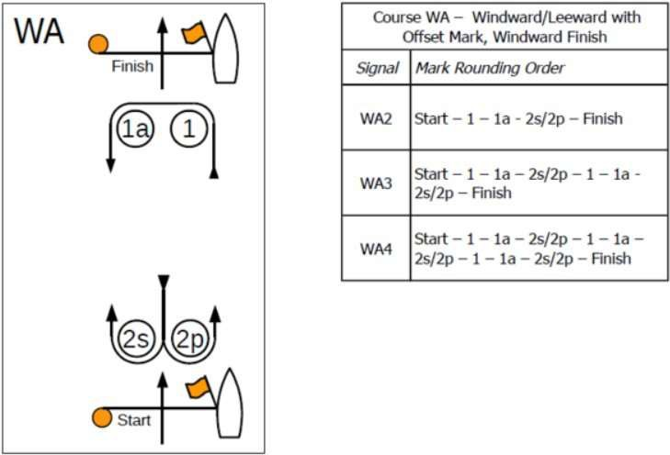
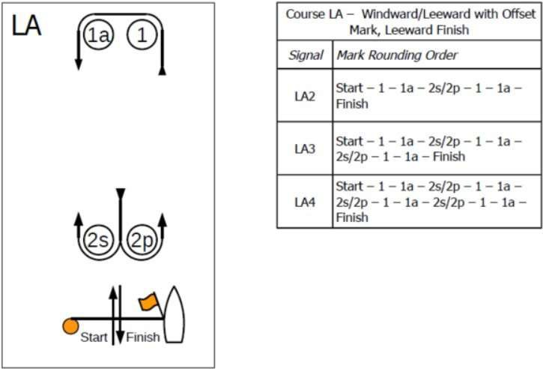

Marks
All Marks will be orange cylinders.

The Start

  - The start will be governed by using RRS 26. Approximately one minute before the warning, a sound or series of sounds may be used to alert that a sequence is about to begin.
  - The starting line will be between a staff displaying an orange flag on the race committee vessel and the course side of the starting mark.
  - RRS A4.2 is changed as stated in NOR/SI 1.3.13.
  - RRS 29.1 is modified as stated in NOR/SI 1.3.1.

Change of the Next Leg of the Course
  - To change the next leg of the course, the race committee will lay a new mark (or move the finishing line) and remove the original mark as soon as practicable.

The Finish
  - The finishing line will be between a staff displaying an orange flag on the race committee vessel and the course side of the finishing mark.
  - Code Flag “A” displayed, with no sound, while boats are finishing indicates “no more racing today.”
  - Code Flag “H” displayed, with no sound, while boats are finishing indicates “racing will continue after a break ashore.”
  - Neither Code Flag “A” nor Code Flag “H” displayed while boats are finishing indicates that another race will follow.

Penalty System
  - Appendix T – Arbitration will apply. Upon receipt of a protest, the protest committee will attempt to have an arbitration hearing as soon as practicable.
    - Rule T1(b) is changed as stated in NOR/SI 1.2.1
    - RRS 44.1 is changed as stated in NOR/SI 1.3.7
    - RRS 44.2 is changed as stated in NOR/SI 1.3.8

Time Limits
  - The following time limits will apply:
- Race Time Limit 90 Minutes
- Finishing Window 20 Minutes
  - Boats failing to finish within the Finishing Window shall be scored TLE (Time Limit Expired), the position of the last boat that complies with RRS 28 to finish plus 2. This changes RRS 35, A4.2, and A11.

Protests and Requests for Redress
  - Protest forms are available at the race office inside the Lake Beulah Yacht Club. Protests and requests for redress or reopening shall be delivered to the race office.
  - Per RRS 61.3, the protest time limit, is 60 minutes after the last boat finishes the last race before coming ashore.
  - RRS 62.2 is changed as stated in NOR/SI 1.3.12.

  - Notices will be posted no later than 30 minutes after the protest time limit to inform competitors of hearings in which they are parties or named as witnesses and where the hearings will be held.
  - Notices of protests by the race committee, technical committee, or protest committee will be posted on the official notice board to inform boats under RRS 61.1(b).
  - A boat that is intending to protest or request redress is requested to notify the race committee after finishing.

Scoring
  - The Scoring system will be Appendix A except as modified by NOR/SI 21.3
  - One (1) race is required to constitute a series.
  - No scores will be excluded from a boat’s series score.

Radio Communication
  - Except in an emergency, a boat that is racing shall not make voice or data transmissions and shall not receive voice or data communication that is not available to all boats [DP]
  - The competitor VHF Channel will be 72.
  - The RC VHF Channel will be 69

Measurement
  - A boat shall comply with RRS 78.1 at all times while racing.

[NP]Prizes
Prizes will be given as follows:
-The Dorn Memorial Trophy will be engraved with the name of the winner. This trophy will remain on permanent display at the Lake Beulah Yacht Club.
Age based rewards are based on your age on the first day of sailing.
-The top 5 overall will receive awards
-The top Master (50-59 years) will receive an award
-The top Grand Master (60-69 years) will receive an award
-The top Mega Master (70-74 years) will receive an award
-The top Ancient Mariner (75 years or older) will receive an award
- The top Youth (under 25 years) will receive an award
-The top Female will receive an award

Disclaimer of Liability
Competitors participate in the regatta entirely at their own risk. See RRS 4, Decision to Race. The organizing authority will not accept any liability for material damage or personal injury, or death sustained in conjunction with or prior to, during, or after the regatta.

Further Information
For further information please contact davidward76@gmail.com,
Robert Atac@gmail.com, regatta chairpersons.

