
The Stonington Harbor Yacht Club

TWENTYFIFTH ANNUAL RED LOBDELL MEMORIAL REGATTA
Saturday, October 3rd, 2026 – 1030 Hrs.

SAILING INSTRUCTIONS

Organizing Authority
  - This regatta is organized by the Stonington Harbor Yacht Club.

Eligibility
  - This regatta is open to all PHRF rated boats 20 ft. loa or longer; all NEMA rated boats and one design classes with three or more entries that appear timely at the starting line. If fewer than two boats of any one design class file entry documents and/or appear at the starting line, they will not be permitted to race. See also Sections 3 and 4, below.

Entry
  - Entry is by means of the standard SHYC Entry Form and Liability Waiver available at the SHYC Clubhouse or online at Club Spot Here. The completed forms, accompanied by a check for the entry fee made payable to SHYC and, except for one designs, a valid PHRF-ECSA or NEMA rating certificate must be received at the SHYC Clubhouse no later than 1000 hrs., Thursday, October 1st .
Competitors less than 18 years old must submit a signed parental consent with the Entry Form.
  - The Entry Fee is $30. If a one design has less than two entries by the entry deadline, entry fees will be returned as soon after the race as feasible to those entrants having paid.

Classes
  - Classes will include:
Class 1: PHRF rated boats 20 ft. loa or longer, spinnakers permitted.
Class 2; PHRF rated boats 20 ft. loa or longer, cruising canvas only, no spinnakers of any type Class 3: NEMA rated multi-hull boats
Class 4: J-24’s, spinnakers permitted but, If less than three J-24’s enter, J-24’s will sail under cruising canvas only as part of class 2. Check scratch sheet for entries.
Classes 5 and up: One design boats with two or more entrants of the same class having filed entry documents and checked in with the Race Committee (RC) at the starting line. Each compliant class will be assigned a separate class number.
There is no limit to the number of classes that can be entered but the RC will review and qualify each class.
  - Classes 1 and 2 races are ECSA points races.
  - The RC will make the final class determination. Assigned classes will be shown on the Scratch Sheet available after 1200 hrs. October 2nd and from the Committee boat until 1010 hrs. on race day.

Rules

  - This regatta will be governed by The Racing Rules of Sailing 2025- 2028 and the prescriptions of The United States Sailing Association (RRS) as modified by these Sailing Instructions (SI’s).
  - Rules 44.1 and 44.2 are changed to a penalty of one turn.
  - In the event of a conflict between the NOR and these SI’s, the SI’s will govern.
  - Sail numbers will be displayed on all boats.
  - All boats in circle 1 will carry VHF radios and monitor VHF 79.
  - All boats intending to race will check in with the Committee boat between 1000 and 1025 hrs. using VHF 79 or by sailing under the Committee boats stern and announcing her intention to race. Classes 5 and higher may check in at their course area until 1325 hrs.
  - Any boat abandoning the race should immediately notify the RC on VHF 79.
  - Engines must be turned off at least 5 minutes before the start of a boats class.

Courses
  - The RC will establish 2 courses for this regatta:
    - The first course will be for classes 1 - 4, established in Fishers Island Sound, use Government Marks for course definition and be 20 to 25 nm in length.
    - The second course will be for classes 5 and up, established in Stonington Harbor between the inner and outer breakwaters and use inflatable yellow and orange tetrahedrons for course definition.
  - Courses will be identified for each start on the Committee Boat course board mounted
on top of the boat’s cabin. Letter codes for each possible Government Mark used for the first and second courses {Classes 1,2,3 and 4) follow:
Assigned Nav.Chart Mark Location
Letter Designation
I/M Inflatable Mark
A | G”9” | Flashing Green Gong at Cerberus Shoal
N | RG”SP” | Red and Green Nun 0.15 nm south of Stonington Point
G | G”3” | Green Gong 0.35 nm SW of the Horn on Middle Ground
 |  | Breakwater, the outer Stonington Breakwater
J | RW “L” | Mo(A) whistle Lord’s Passage. (Boats must pass between Can “7”
 |  | and N “2L” in Lord’s Passage.)”
B | R”6” | Flashing red bell at Napatree Point Ledge
Y | N”16” | Red Nun at southeast end of Eel Grass Ground
R | R”20” | Red Bell south of Ram Island Reef
E | “Fl 4 Sec” | Seaflower Reef 1 nm south of Mumford Cove
M | C”1” | Green can at mouth of Mystic River
L | RB “DIR” | Red and black can at Intrepid Rock
C | RW “SE” | Red & white Whistle 0.1 nm west of Silver Eel Cove, Fishers Is.
F | R”4” | Red flasher and bell 1 nm south of Bartlet Reef
K | R”2” | Red Nun SW Race Pt Fishers Island. Note: Boats may not pass
 |  | between red bell # 2 and North Hill on Fishers Island."

  - The letters assigned to define the first and second courses will be displayed on the course board in order of rounding. Letters P and S indicate the preceding mark(s) are to be left to Port or Starboard. S/F indicates the start and finish lines which will be the same unless the course is shortened. Examples: R N P S/F indicates marks R and N to be left to port and then to finish. R F P Y S S/F indicates marks R and F to be left to port, mark Y to starboard, then to finish.

`

The Start
  - The Starting/Finish Line for the first circle (Classes 1, 2, 3 and 4) will be in Fishers Island Sound. It will be between an orange flag on the RC Committee Boat and a small
orange tetrahedron off the port side of that boat.
The boat will be anchored south of Stonington Harbor and Wamphassuc
Point. If any race is shortened, it will be done in accordance with RRS Rule 32. Be aware that the RC boat that starts any race may not be the same boat that is at the finish line. Any official RC boat will display a blue or yellow RC flag.

  - The Starting Line for Class 5 and above will be in Stonington Harbor between the inner and outer breakwaters. It will be between an orange flag on the RC boat and a small orange buoy to the port side of the boat. The Finish Line will be between a blue flag on the starboard side of the RC boat and a small orange buoy to starboard of the boat.

  - The Class Flag for each class will be the numerical pennant for the class number.
  - The Scratch Sheet will assign numbers for each class and assign each boat to the appropriate class. See 4.3 above.
  - Classes 1, 2, 3 and 4 will be started using the 5 minute sequence of RRS Rule 26. Time Until Start Signal Flag Sound
5 minutes Warning Class Flag Up 1 Horn 4 minutes Preparatory ‘P’ Flag Up 1 Horn
1 Minute One Minute ‘P’ Flag Down 1 Long Horn 0 Minutes Start Class Flag Down 1 Horn
  - Classes 5 and above will be started using the 3-minute sequence as follows:
3 Minutes | Warning | Class Flag Up | 1 Horn
2 Minutes | Preparatory | ‘P’Flag Up | 1 Horn
1 Minute | One Minute | ‘P”Flag Down | 1 Long Horn
0 Minutes | Start | Class Flag Down | 1 Horn.

  - Before the Starting Signal, any postponement will be indicated by the display of Pennant “AP” with two horn sounds.
  - Individual recalls for being OCS will be indicated by display of Flag “X” and one horn regardless of the number of boats being recalled. The RC will attempt to hail boats OCS on VHF 79. Boats so recalled and failing to return and restart will be assessed a 20 minute penalty for classes 1 through 4 and drop 1 place in scoring for classes 5 and above.
RRS 29.1 is modified accordingly.
  - General Recalls will be signaled in accordance with RRS Rule 29.2
  - First warning for classes 1, 2, 3 and 4 will be at approximately 1030 hrs. Classes may be started in numerical sequence or some classes may be combined for a joint start.
Watch the starting sequence signals.
  - First warning for classes 5 and higher will be at approximately 1330 hrs. Again, some classes may be joined for a combined start.
  - There will be no rolling starts. Time between starts for different classes may vary.

Scoring
  - PHRF rated boats competing in classes 1, 2 and 4 will be scored time on time by class. NEMA rated boats will be scored time on time. One design boats sailing as a class (class 5 and above) will be scored Low Point, RRS Appendix A.
  - Any boat not finishing its race(s) by 1700 hrs. will be scored DNF. This changes RRS Rule 35.
  - The PHRF Spinnaker Class race (class 1) and PHRF Cruising Canvas race (class 2) are ECSA points races.

Protests

  - A boat that has taken a 360 degree penalty turn under RRS Rule 44.2, as modified above Will notify the RC on VHF 79 immediately after the race describing the incident.
  - A boat intending to file a protest will so notify the RC on VHF 79 immediately upon conclusion of its race and, within one hour of docking, deliver to the RC a written protest detailing the incident, the boats involved and the RRS rule violated. The RC will schedule a hearing by the Protest Committee as soon as possible after receiving the written protest. Any race in which a protest occurs will not be scored until the protest is decided.

Liability

  - Each boat’s Captain must sign the Liability waiver accompanying the Entry form as noted in 3.1, above and each crew member must sign, or have signed within the year, the crew liability form . These forms are available along with the Entry Form at www.shyc.us/racing.

Awards

  - First, second and third place awards for each class will be given at the Shore Party following the regatta. The Red Lobdell Memorial Trophies will be awarded to the winners of the PHRF Spinnaker, PHRF Cruising Canvas and NEMA classes.

Shore Party
  - A Shore Party will be held at SHYC following the regatta See NOR Section 7 for details.

Additional Information
  - For additional information, email the Race Chairmen Brandon Watson
watson1247@gmail.com, 914-420-7648 or Amy Fraher amylfraher@gmail.com
619-436-9855 or call the SHYC Clubhouse at (860) 535-0112.
.

.

Please see mark locations on following two pages

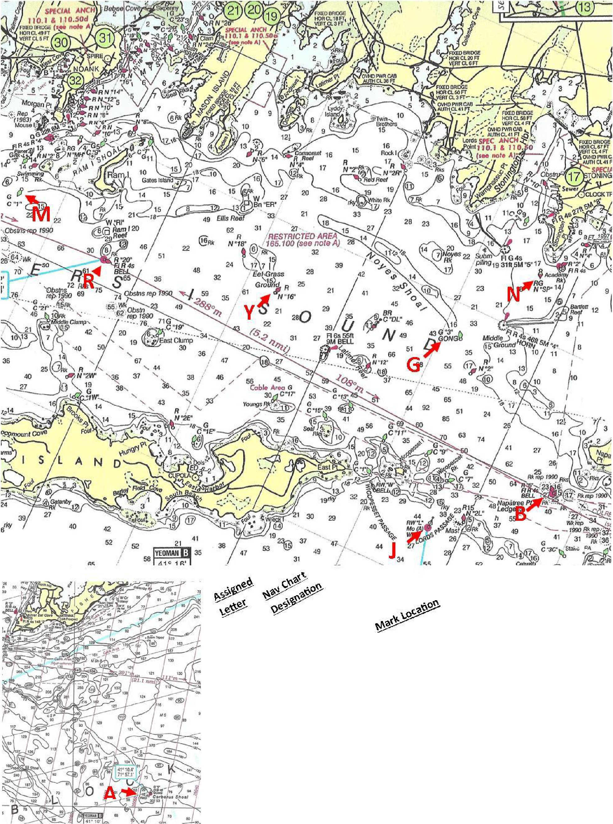
13

10 7

h

10

46
s
62 '-Z_

A | G"9" | Flashing Green Gong at Cerberus Shoal
N | RG"SP" | Red and Green Nun 0.15 nm south of Stonington Point
G | G"3" | Green Gong 0.35 nm SW of the Horn on Middle Ground
 |  | Breakwater, the outer Stonington Breakwater
J | RW"L" | Mo(A) whistle Lord's Passage. (Boats must pass
 |  | between Can "?"and N "2L" in Lord's Passage.)"
B | R"6" | Flashing red bell at Napatree Point Ledge
y | N"16" | Red Nun at southeast end of Eel Grass Ground
R | R"20" | Red Bell south of Ram Island Reef
M | C"1" | Green can at mouth of Mystic River

278

215

filOrE 8
--
,-,,._-ff-.,,�-- ONICEA Atie-.
�VM. AlftCRAFT GARDIN£
PO!N1' TARGl!T
46

-.......:

��.,n.,.
��•rw:hclrir-,
olh: l'IUINSG
oean:r•a�

E "Fl 4 Sec" Seaflower Reef 1 nm south of Mumford Cove
L RB "DIR" Red and black can at Intrepid Rock

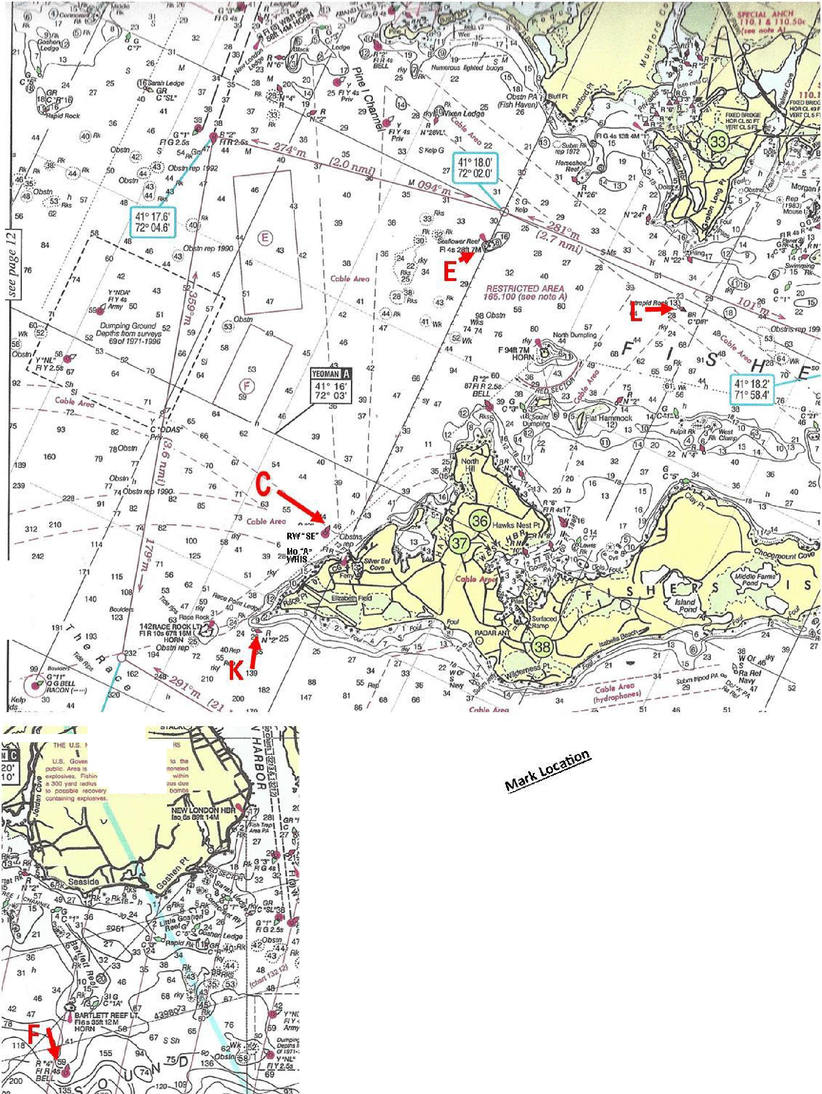
F R"4" Red flasher and bell 1 nm south of Bartlett Reef
C RVV "SE" Red & white whistle 0.1 nm west of Silver Eel Cove, Fishers Is.
K R"2" Red Nun SVV Race Pt Fishers Island. "Note: Boats may not pass between red bell# 2 and North Hill on Fishers Island."

