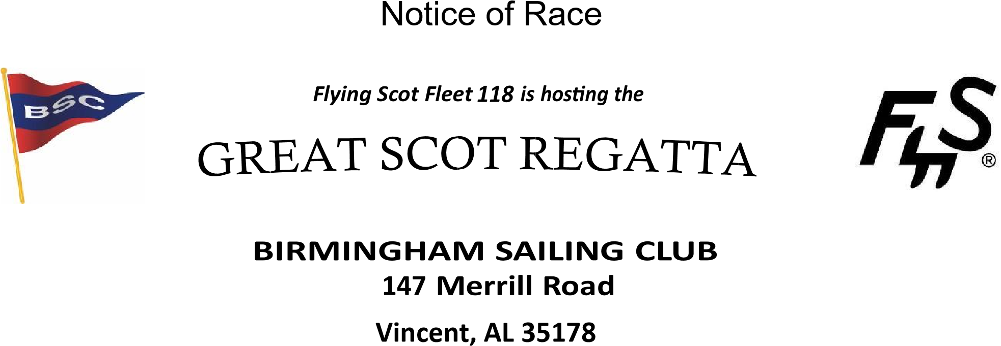

October 24-25, 2026

Organizing Authority: This regatta is organized under the authority of the Birmingham Sailing Club and will be sailed under the management of its race committee.

Rules: This regatta will be governed by the rules as defined by the current edition of the Racing Rules of Sailing (RRS) except as these may be modified by this Notice of Race, the Flying Scot Class Rules, the Sailing Instructions, and any amendments thereto. The Low-Point Scoring System will be used to score the regatta, except that there will be no throw-outs. See Sailing Instructions for more detail. Sailing Instructions will be provided at registration.

Eligibility: This regatta is open to all Flying Scot sailboats. Championship and Challenger Fleets will be scored, sailing in separate Starts. Awards will be presented to the top three finishers in both fleets.
We are using the following rules from the FSSA for sanctioned regattas: Crew. The same crew (number and persons) shall be carried throughout all races of the event. Each competing boat shall be manned by at least 2 persons.

Races: Five races are planned – with three on Saturday and two on Sunday. If time, wind, and racing conditions permit, more races may be run on either day for a total of 5 races completed. One race shall constitute a regatta. Courses to be sailed will be described in the Sailing Instructions.

Registration & Fees: Registration online is required by October 23 at the BSC website. Early registration is required by October 21 for meal preparations. Registration Entry Fee is $110 per boat and includes all meals and beverages for skipper and one crew for the weekend. Extra meals may be purchased for $25 per person at Registration.
Registration / Event Page Link:
https://birminghamsailingclub.org/regatta/5ADJMP66an

Schedule:
FRIDAY, 23 October
• 1:00 PM | BSC club facilities will be open
• 5:30 PM  SATURDAY, 24 October | Complimentary Burger Cookout at the BSC Clubhouse
- 9:00 to 11:00 AM Check-in
- 11:30 AM Competitors Meeting (Lunch to follow)
- 1:00 PM Warning signal for first race. More races to follow
- Attitude Adjustment begins as soon as possible after the final Saturday race with refreshments and appetizers
- 6:30 PM Dinner, After Dinner we hope to have a band for entertainment

SUNDAY, 25 October
- 8:00 AM Complimentary Breakfast & Coffee
- 9:30 AM Warning signal for first race. More races to follow
- No warning signal for an additional race will be made after 12:00 PM
- 12:30 PM Lunch will be served
- The Awards will be presented after lunch is served

Lodging: BSC member homes may be available on a limited First Come - First Served basis.

Hotels: There are hotels within a twenty-minute drive of BSC. Below are some of the nearest:
Hampton Inn (on I-20) 205-814-3000
Holiday Inn Express (on I-20) 205-884-0047
Comfort Suites (on I-20) 205-729-6045
Lake Front Motel 4304 Martin St 205-338-3344

As of 9-29-2026 we have become aware that there are no rooms at the above hotels due to the races at Talladega Motor Speedway the same weekend as our regatta. We were able to secure 8 rooms at described below. They are about 25 to 35 minutes from the Birmingham Sailing Club in Sylacauga, Alabama.

Motel Name: Roadway Inn (Soon to be Quality Inn after remodel)
Address: 40 Curtis Lyles Ct, Sylacauga, Al
Phone: (256) 245-4141
Room Block: Stan Graham (Birmingham Sailing Club)
Rate: $110.00 per nite
Additional Contact: Stan Graham (229) 224-5002

24 miles from the club...about the same drive time as staying in Pell City with all the traffic lights.

--
Stan Graham
100 Merrill Rd
Vincent, Al 35178
229.224.5002

Camping & Club Facilities: Tent camping is available on Birmingham Sailing Club grounds, as well as a few RV parking spots without hookups. Shower facilities are available in the clubhouse. Grounds and clubhouse will be available on Friday afternoon. Please leave your pets at home.

Loaner Boats:
Need a Scot to Attend? There may be extra Scots available for loan if you don’t want to bring yours for the regatta. First Come - First Served for requests to borrow a boat.

Physical Address:
Birmingham Sailing Club
147 Merrill Road
Vincent, AL 35178

BSC Website:
www.birminghamsailingclub.org

For additional information, special requests, please contact Bill Massey at the following:

205-873-4305 Cell Email: epsmwam@bellsouth.net

