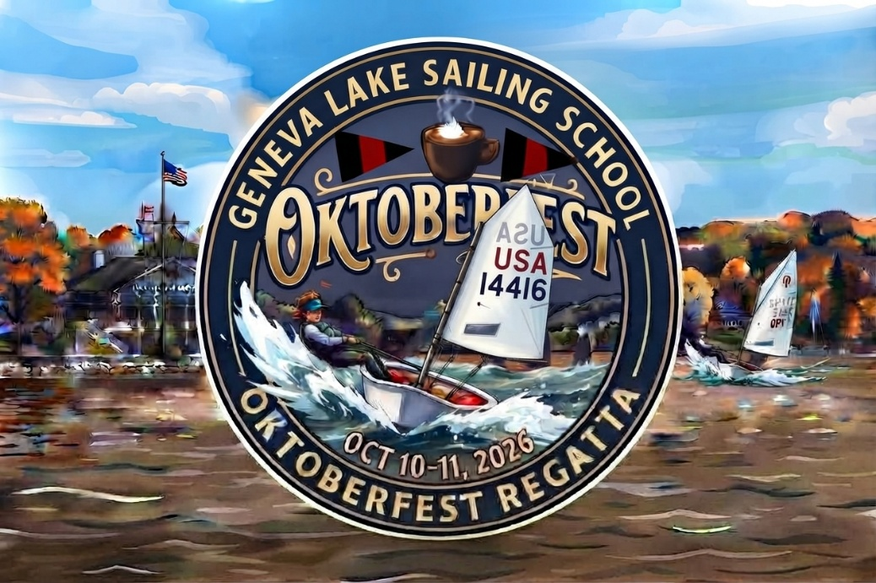

Sailing Instructions – Includes Amendment 1
Sailing is an activity that has an inherent risk of damage and injury. Competitors in this event are participating entirely at their own risk. See RRS 3, Decision to Race. The race organizers (the organizing authority, race committee, protest committee, host club, sponsors, or any other organization or official) will not be responsible for damage to any boat or other property or the injury to any competitor, including death, sustained as a result of participation in this event. By participating in this event, each competitor, or in the case of minors, each competitor’s parent or guardian agrees to release the race organizers from any and all liability associated with such competitor’s participation in this event to the fullest extent permitted by law.
- RULES The regatta will be governed by the rules as defined in the current Racing Rules of Sailing and the prescriptions of US Sailing.
- ENTRIES The regatta is open to Optimist and ILCA.
- NOTICES TO COMPETITORS Notices to competitors will be posted online
- CHANGES TO SAILING INSTRUCTIONS Any changes to the sailing instructions will be posted no later than 90 minutes before the first warning signal on the day it will take effect. Except that any change in the schedule of races will be posted by 1800 on the day before it will take effect.
- SIGNALS MADE ASHORE
  - Signals made ashore will be posted on the Flagpole.
  - When the Answering Pennant (“AP”) is displayed ashore, ‘1 minute’ is replaced with ‘not less than 30 minutes in the Race Signals AP’.
- NUMBER AND SCHEDULE OF RACES
  - Six races are scheduled.
  - Warning signal for the first race is Saturday, October 10th, 10:45a.m. Except when races are sailed back-to-back, the time of the warning signal for subsequent races will be posted online.
  - The first warning signal on Sunday October 11th, is at 09:45 am.
  - No warning signal for a race shall be made after 1 p.m. on Sunday October11th, 2026.
- CLASS FLAG The Optimist Class Flag will be a flag with a class logo. The ILCA class flag will be a white flag with M14.
- RACING AREA The racing area will be the navigable waters of Geneva Lake north of the Geneva Lake Sailing School
- THE COURSE
  - The courses and their designations are shown as COURSE ILLUSTRATIONS.
  - When there is a gate, boats shall sail between the gate marks from the direction of the previous mark and round either gate mark. If only one mark of the gate is present, it should be rounded, leaving it to port.
- MARKS
  - For RWB and ILCA, The starting mark will be a Yellow or Green MarkSetBot.
  - For RWB and ILCA, Marks 1,2,3, & 4 will be Pink MarkSetBots.
  - For Green Fleet, marks will be orange balls.
- THE START
  - Races will be started according to US Sailing Prescription – Appendix U – Audible Signal Racing System (3-minute “whistle start”).
  - The starting line will be a staff displaying an orange flag on the RC boat at the starboard end of the line and the course side of a yellow MarkSetBot on the port end.
  - ILCA and Optimist class will start separately. The starting order may change and will be announced prior to each race.
- CHANGE OF THE NEXT LEG OF THE COURSE
  - To change the next leg of the course, the race committee will either move the original mark (or the finishing line) to a new position, or the RC will lay a new mark and remove the original mark as soon as practicable. Changes less than 10 degress or 0.1 nautical miles that occur before any boat begins the leg may not be signaled.
  - The RC may adjust marks without further signaling to maintain the appropriate course configuration.
- THE FINISH The finish line will be between a staff displaying an orange flag on a Race Committee boat on port end and the course side of a yellow MarkSetBot on the starboard end.
- TIME LIMIT
  - The time limit for the first boat to finish a race will be 60 minutes.
  - Boats still racing 20 minutes after the first boat sails the course and finishes will be scored in their current position. This changes RRS 35 and A4.1.
- PROTEST AND REQUESTS FOR REDRESS
  - A boat intending to protest about an incident that occurs in the racing area shall notify the RC finish boat of her intention, including the sail number of the boat (s) being protested. This changes RRS 60.4 (a).
  - Protests shall be written on forms available in the Geneva Lake Sailing School building and delivered there within the protest time, which will end 30 minutes after the signal boat docks. The docking time will be posted.
  - Notices of protests and requests for redress will be posted within 20 minutes of the expiration of the protest time limit or receiving the relevant information to inform competitors of hearings in which they are parties or named as witnesses. Hearings will be held at a location at Regatta Headquarters or another physical or virtual location as deemed necessary by the jury.
  - Notice of a request for redress including the nature of the request and the grounds on which it is filed shall be considered to fulfill the requirements of the prescription to RRS 63.2
- SCORING The Low Point System in Appendix A of the RRS will apply. Each boat’s series score shall be the total of her race scores, except for if six races are completed, the boat’s series score shall be the total of her race scores excluding her worst race score. One race shall constitute a regatta.
- DISPOSAL OF TRASH Trash may be placed aboard official vessels or support person vessels. Boats observed purposefully discharging trash into the water will either be disqualified from all races sailed on the day the infraction is observed or be subject to other suitable disciplinary action or both.
- SAFETY
  - Each competitor, including skipper and crew, their parents, or legal guardians, are ultimately responsible for competitor’s safety.
  - All competitors shall wear, while on the water, a properly fastened U.S. Coast Guard approved PFD in good condition that is entirely dependent on foam for its flotation.
  - A boat that retires from a race shall notify an RC boat before leaving the racing area, or, if that is not possible, notify a regatta official at Regatta Headquarters immediately upon arrival on shore.
  - Boats that are not leaving the harbor to race shall inform Regatta Headquarters or a regatta official prior to the start of the first race of the day.
- SUPPORT AND COACH BOATS Except when rendering assistance to a person believed to be in danger, support and coach boats shall stay outside of the area where boats are racing from the time of the warning signal until the boats have finished and are well clear of the finish line and course. Coaches are allowed to assist green fleet level Optimist sailors; this aid shall be limited to basic instruction helping the sailors sail the course.
- MEDIA RIGHTS
  - Competitors give absolute right and permission for video footage or photographs of themselves, or their boat generated during the event to be published in any media for press, editorial, educational, or advertising purposes.
  - Remotely controlled aircraft (drones) are not allowed to be flown in the racing area without the permission of the organizing committee. Photos or videos captured by a drone must not be shown to the competitors between races for coaching purposes and must be made available for general viewing purposes.

