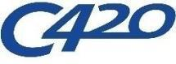  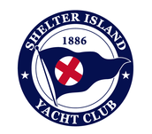 | 2026 C420 ATLANTIC COAST CHAMPIONSHIP  August 6-7, 2026  Organizing Authority (OA): Shelter Island Yacht Club  in conjunction with the Club 420 Association, Inc.  NOTICE OF RACE

Section 4.2 is amended as follows:
4.2. Schedule of Events
DATE | TIME | EVENT
Thursday, August 6 | 0900  1000  1100  1200  1300  1800 | Check in  Coaches Briefing  Competitors’ Meeting  Harbor Start  First Warning Signal  No Warning Signal After This Time
Friday, August 7 | 1000  1030  1200  1300  1600  TBA  TBS | Coaches Briefing  Competitors’ Meeting  Harbor Start  First Warning Signal  No Warning Signal After This Time  Awards Reception  Competitors Depart

