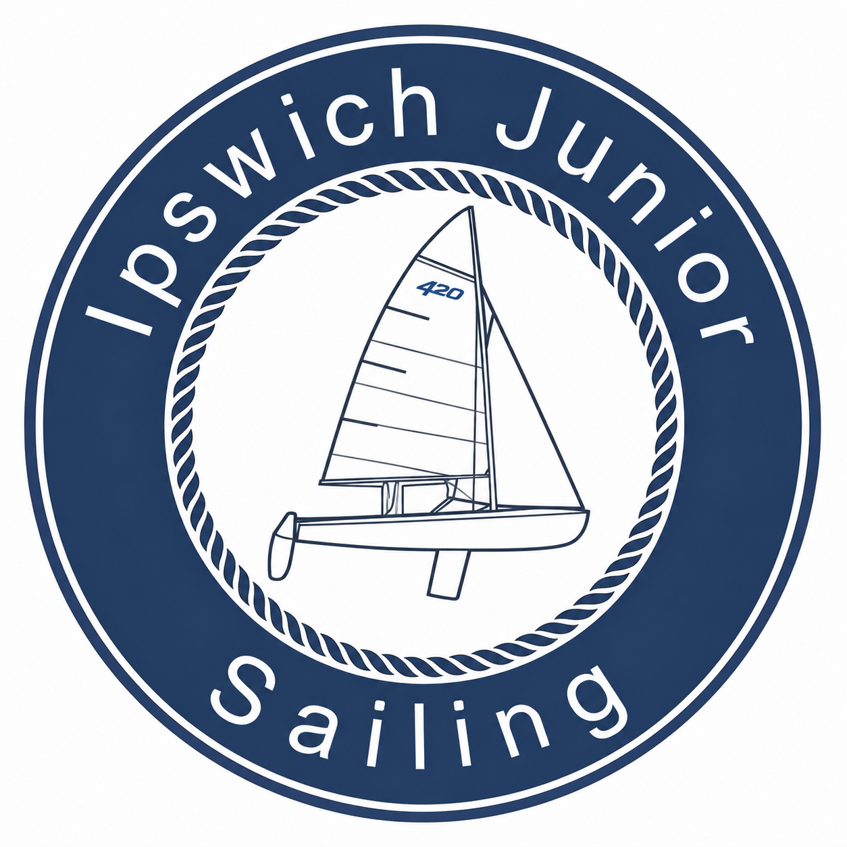
NOTICE OF RACE
Ipswich Junior Sailing — Greenhead Regatta
Club 420 and Optimist Classes
Friday, July 31, 2026
The Organizing Authority (OA) is Ipswich Junior Sailing (IJS).
1. RULES
1.1 The event is governed by the rules as defined in The Racing Rules of Sailing 2025–2028 (RRS) and this Notice of Race, except as modified in the Sailing Instructions.
1.2 Information and documents will be posted on the Official Notice Board, located on the IJS Clubspot event site, no later than 0800 on July 31, 2026.
1.3 RRS 40 is changed as follows: competitors shall wear a US Coast Guard (USCG) approved Type III personal flotation device (PFD), of the appropriate size for the sailor, at all times while launching boats, on the IBYC/IJS docks, and on the water, except for brief periods while adding or removing clothing.
2. ELIGIBILITY AND ENTRY
2.1 This event is open to sailors of all ages.
2.2 The regatta is open to boats of the Club 420 and Optimist classes. Boats shall conform to Club 420 class rules and Optimist class rules, respectively. Spinnakers are permitted for use in the Club 420 class.
2.3 The event will be sailed as two fleets: Club 420 and Optimist.
2.4 There is no entry fee for the Greenhead Regatta.
2.5 There is no hard registration deadline, as IJS welcomes as many sailors as possible. However, competitors are strongly encouraged to register in advance on the IJS Clubspot event site, or to contact us (see Section 9), so that IJS can plan fleets, food, and race committee resources accordingly.
2.6 All required waivers must be completed via Clubspot for a competitor to be eligible to race.
2.7 Competitors must personally present themselves at check-in to be scored in the regatta.
3. VENUE
3.1 The regatta will be held at Ipswich Bay Yacht Club (IBYC), adjacent to Crane Beach, Ipswich, MA.
3.2 Competitors are welcome to arrive by land or by sea. A boat ramp is available at Ipswich Bay Yacht Club, and another is available nearby at the Ipswich Town Wharf.
3.3 Racing will take place in the general vicinity of Ipswich Bay; the final location of the starting line will be at the discretion of the OA based on wind and tide, and will be described in the Sailing Instructions.

4. SCHEDULE
Time | Event
8:30 – 9:30 am | Boats raft up to IJS floating dock; check in on IBYC lawn
9:00 – 10:00 am | Light breakfast (bagels, pastries, juice boxes, and water)
10:00 am | Skippers' meeting
11:00 am | Warning signal
3:30 pm | No races to begin after this time; awards ceremony to follow

4.1 The schedule above is subject to change; any changes will be posted on the Official Notice Board and announced at the skippers' meeting.
5. SAILING INSTRUCTIONS
5.1 Sailing Instructions will be available on the IJS Clubspot event site and posted on the Official Notice Board no later than the morning of the event.
6. SCORING
6.1 The Low Point scoring system of RRS Appendix A will be used.
6.2 One (1) race constitutes a regatta.
6.3 When five (5) or more races have been completed, a boat's series score will be the total of her race scores excluding her worst score.
7. PRIZES
7.1 Prizes will be awarded first through third place in each class that receives a start, for skipper and crew in the Club 420 class and for skipper in the Optimist class.
7.2 Awards will be presented immediately following the conclusion of racing and confirmation of results.
8. RISK STATEMENT
RRS 4 states: ‘The responsibility for a boat's decision to participate in a race or to continue racing is hers alone.’ By participating in this event, each competitor acknowledges that sailing is a potentially dangerous activity with inherent risks, including strong winds and rough seas, sudden changes in weather, failure of equipment, boat handling errors, poor seamanship by other boats, loss of balance on an unstable platform, and fatigue resulting in increased risk of injury. Inherent in the sport of sailing is the risk of permanent, catastrophic injury or death by drowning, trauma, hypothermia, or other causes.
9. FURTHER INFORMATION
For further information, or if you're thinking of joining us, please contact:
Ryan MacNeille, Program Manager
Ipswich Junior Sailing
ryan.macneille@ipswichjuniorsailing.org

