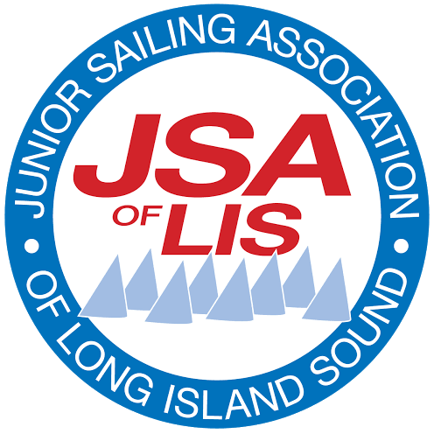
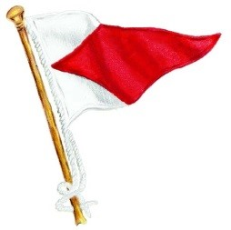
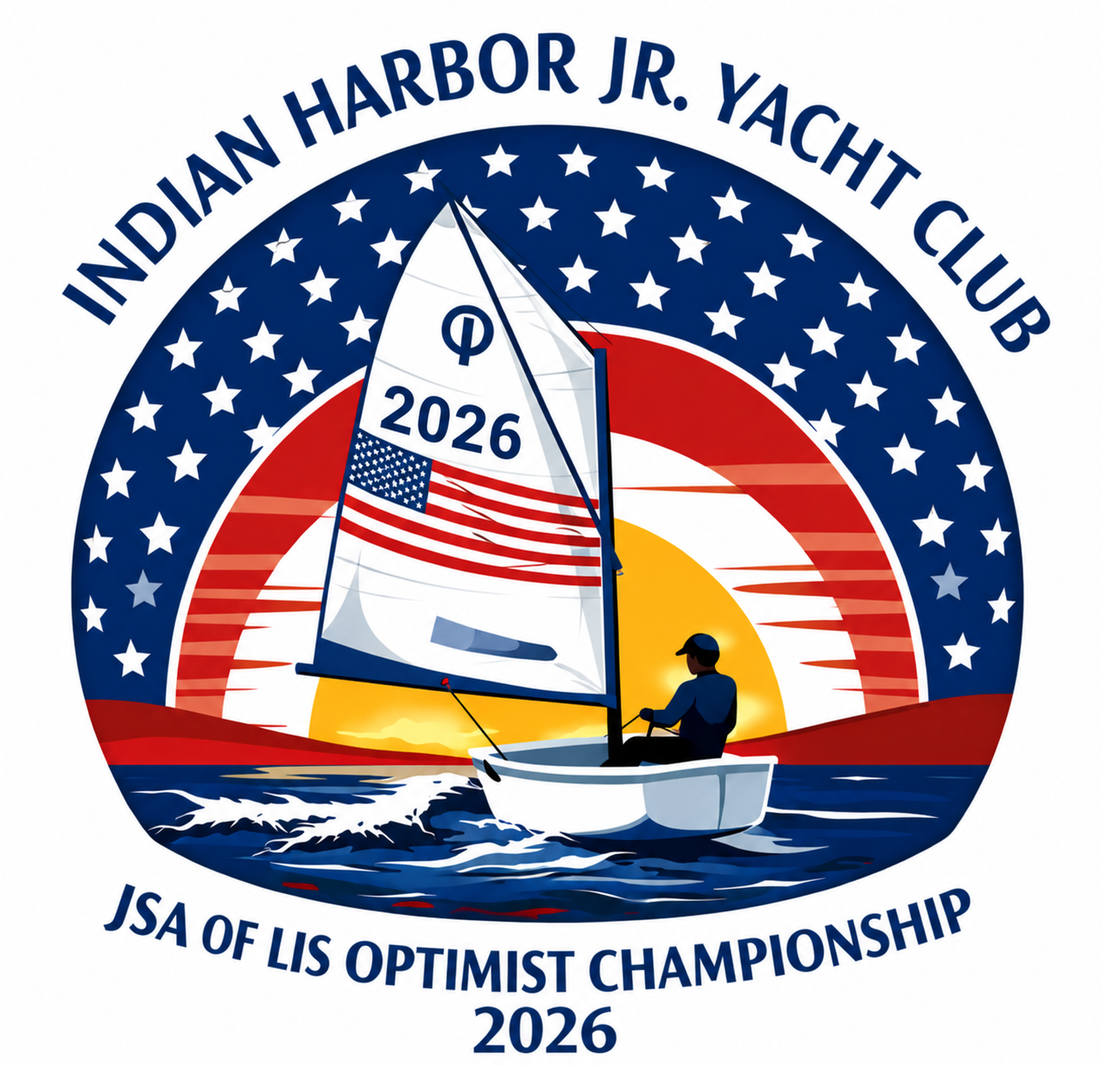
2026 JSA of LIS Optimist Championship
Indian Harbor Yacht Club
Greenwich, CT

August 8th & 9th, 2026

Class: Optimist

Open to: All boats of the Optimist Class Red, Blue and White age groups that meet JSA and regatta eligibility requirements, including qualification for JSA Opti Champs as listed at https://jsalis.org/qualifying-jsa-champs-and-season-series.

NOTICE OF RACE

OA: Indian Harbor Yacht Club is the OA in partnership with the Junior Sailing Association of Long Island Sound
[DP] The notation ‘[DP]’ in a rule means that the penalty for a breach of the rule may, at the discretion of the protest committee, be less than disqualification.
[SP] denotes a rule to which a standard penalty from the “USODA Graded Penalty System” may be applied by the race committee or technical committee without a hearing, or a discretionary penalty applied by the protest committee with a hearing. This changes RRS 60.5(b) and A5.1.

Abbreviations:
PC - Protest Committee
RC - Race Committee
OA - Organizing Authority
SI - Sailing Instructions
RRS - Racing Rules of Sailing 2025-2028
NOR - Notice of Race
JSA - Junior Sailing Association of LIS

- RULES
  - The event is governed by:
    - The rules as defined in The RRS.
    - The Optimist Class Rules
    - The Rules for JSA Events
    - The JSA Code of Conduct
    - The US Sailing Athlete Safety Policy Handbook
  - RRS Appendix V1 Penalty at the Time of an Incident, and Appendix V2, Post-Race Penalties, will apply.
  - [SP][DP] RRS 40.1 will apply at all times while afloat.
  - [DP][NP] Competitors and support persons shall comply with any reasonable requests from an event
  - official. Failure to comply with requests may be considered misconduct.
  - Rule 60.4(a)(2) is changed as follows: (2) if it alleges a breach of a rule of Part 2 or rule 31 and is from a boat that was not involved in, and did not see, the incident, or

- SAILING INSTRUCTIONS
  - The Sailing Instructions will be available at the event’s official notice board and event site via The Clubspot (Link: https://theclubspot.com/regatta/aAMMNWDd8v)
  - The sailing instructions will be posted no later than Friday August 7th at 1700

- COMMUNICATION
  - The Notice of Race, Results and Official Notice Board will be available via The Clubspot.
  - [DP] Each coach and support vessel shall carry a VHF radio capable of communicating on all US channels.
  - [DP] All coaches and support vessels shall monitor a VHF channel which will be announced at the coaches Meeting. Coaches and support persons shall maintain silence on this channel unless safety-related communication with the race committee or safety patrol is necessary.
    - Indian Harbor Yacht Club Marine Facilities & Launch can be reached on VHF channel 68 for operational and emergency support.
  - [DP] While racing, from the first warning signal until the end of the last race of the day, except in an emergency, a boat shall not make voice or data transmissions and shall not receive voice or data communication not available to all boats.

- ELIGIBILITY & ENTRY
  - This regatta is open to all competitors who meet JSA and regatta eligibility requirements, including qualification for JSA Optimist Champs.
  - The regatta is open to JSA members’ racing boats of the Optimist Class that meet the age requirements set forth below and who have also been certified as competent for this event by, and are under the aegis of, the Head Instructor or Program Chair of the Junior Sailing Program at their club, or a similar competent organization.
  - Eligible boats may enter by registering online at The Clubspot (https://theclubspot.com/regatta/aAMMNWDd8v). To be considered an entry in the event, a boat shall complete all registration requirements and pay all fees.
  - Questions regarding registration should be directed to cfoley@indianharboryc.com. Questions regarding qualification for JSA Optimist Champs should be directed to info@jsalis.org.
  - Coaches shall be registered and their registration must include their cell phone and email address.

Age Group Fleet | Age (On First Day of Event) | Notes
White | 10 or younger
Blue | 11 or 12
Red | 13 to 15 | Competitors shall not reach their sixteenth (16th)  birthday in the current calendar year.

- FEES
  - The entry fee is $200 per sailor due by August 5th at 2359. The fee for entries submitted after the due date is $220 per sailor. No refunds of the entry fee will be made after Wednesday, August 5th at 1730.
  - There is no fee to send an Instructor.
  - All sailors and instructors are required to check in (in person) during Registration.

- SCHEDULE

Day | Date | Time | Activity | Location
Friday | August 7th | 1700 - 1930 | Pre-Registration and boat drop | Registration on East Property &  Sunfish Bar/South Patio
Saturday | August 8th | 0745 - 0845 | Registration Reopened  (Breakfast) | Registration on East Property &  Sunfish Bar/South Patio
 |  | 0915 | Competitors Meeting | South Patio
 |  | Following Competitors Meeting | Coaches Meeting
 |  | 1030 | Harbor Start & Launch
 |  | 1130 | First Warning Signal
 |  | 1630 - 1830 | Dinner, Music & Raffle | South Patio
Sunday | August 9th | 0800 - 0900 | Competitors Arrive  (Breakfast)
 |  | 0845 | Coaches Meeting | South Patio
 |  | 0900 | Competitors Meeting | South Patio
 |  | 0930 | Harbor Start & Launch
 |  | 1030 | First Warning
 |  | 1530 | No Warning Signal After This Time
 |  | Post Racing | Hot Meal, Ice Cream & Awards

- MEASUREMENT, SAFETY & EQUIPMENT
  - Each competitor boat shall carry the safety equipment specified by either the Optimist Class Association or JSA.
  - This Opti Safety Inspection Checklist form (available at the event Clubspot) must be completed and signed by the competitor coach at registration.
  - It is the responsibility of coach(es) from each club to ensure that their sailors’ boats are seaworthy. Instructors/Coaches signatures will be required on all Safety Check forms submitted at registration.
  - [DP] Each boat shall display a streamer designating their Division (Red, White, Black, Sky Blue) from the top of their sail at the Sprit Pole Loop. Streamers will be provided at registration.
  - [DP] Each program’s Coach must sign out and sign in their sailors, daily at the registration desk when launching and upon return.

- VENUE
  - The racing area will be inside of Great Captain Harbor or South of the Greenwich Islands in the Long Island Sound, all south of Indian Harbor Yacht Club.
  - NOTE: All Sailors and Coaches will adhere to and avoid restricted areas in the harbor as outlined in the “GREAT CAPTAIN HARBORHAZARDS” map attached on the event’s Clubspot
.
- COURSES
  - The course to be sailed will be the JSA Opti Champs course as described in the Sailing Instructions.

- SCORING
  - The Race Committee will run as many races as possible.
  - One race or “Set” of races is required to constitute a series.
  - Rule 90.3(e) will be in effect.

- PRIZES
  - Prizes will be awarded to first through fifth overall, first through fifth per Red, White and Blue fleet, and the top three girls following the completion of racing.
  - A sportsmanship award may be awarded at the discretion of the race committee.

- SUPPORT VESSELS
  - Any program entering three or more boats shall supply an instructor with a support vessel equipped with a working VHF radio, an anchor and a first aid kit.
  - Any program entering fewer than three boats that will not supply a support vessel shall arrange with another program to allow the supervising coach out onto the water. In no circumstance shall competitors be allowed to sail without a designated instructor on the race course.
  - [DP] All support vessels shall be equipped with a functioning engine safety cut-out switch which shall remain attached to the operator at all times while the engine is running.
  - [DP] Coaches shall register with the OA at registration.
  - [DP] Coaches shall attend the Coaches Meeting to receive safety assignments.

- DRONE USAGE
  - Drones are not allowed at the event unless they are authorized by the Organizing Authority (OA). Content from OA authorized drones should not be used for coaching during the event. If the content is used for coaching (or other similar purposes) it shall be made available to all competitors at the same time and not during competition hours. Further, the content shall be made available to the JSA for promotional purposes by promptly emailing said content to news@jsalis.org.

- TRANSPORTATION AND PARKING
  - [DP] Neither competitor nor coach boats may arrive before August 7th at 1630.
  - [DP] For competitor boat drop off, please see PARKING LOT DROP OFF MAP and lot allocation by visiting Club under tab 2 at the “COACH BOAT HOIST RESERVATION” link.
  - [DP] TRAILERS: from Area B competitors must leave the property, while trailers from Area A and C will be stored in the north end of the Club’s Main Parking Lot in the “Dry Sail Area” marked “Trailer Storage”
  - [DP] Coach boats arriving by trailer must bring their own lifting bridal and register for hoist slots here: COACH BOAT HOIST RESERVATIONS.
  - [DP] All other coach boat arrivals, please announce yourself in the harbor for dock or mooring assignments via VHF CH 68 and head to the south end of Indian Harbors MAIN DOCK north of Launch Dock (not East Property)
  - [DP] PARKING: No Parking should be expected for visitors at the Main Clubhouse. All parking (following boat drop off) will be redirected to IHYC Overflow Parking at: 660 Steamboat Road (Free)- or - the Greenwich Train/Island Beach Lot (Free after 5PM, $7 from 9-5PM on Saturday)

- RISK STATEMENT

RRS 3 states: ‘The responsibility for a boat’s decision to participate in a race or to continue to race is hers alone.’ By participating in this event and any related activity sponsored, undertaken, administered, managed, or allowed to be conducted by Indian Harbor Yacht Club, the owner, helmsman and each crew member agree, understand and accept, for themselves and their respective successors, assigns, representatives, administrators, executors, agents, heirs or any person acting or purporting to act on their behalf (“Releasors”) that sailing is an inherently dangerous and unpredictable activity due to multiple factors that cannot be anticipated or predicted with certainty, including but not limited to weather, equipment failure or malfunction, and the actions of others on or off the water, injury, sickness and disease (including communicable diseases such as Covid-19). Releasors also agree, understand
and accept that sailing presents inherent risks of serious bodily injury (including permanent disability, paralysis, and death, whether by drowning or otherwise, sickness and disease (including communicable diseases), property damage and other economic loss. Accordingly, and in consideration for being permitted to enter into and participate in this or any other sailing event sponsored, undertaken, administered, managed or allowed to be conducted by Indian Harbor Yacht Club, Releasors forever release and waive, to the fullest extent allowed by law, any and all claims, actions, accounts, causes of action and choses in action, whether in law, equity or admiralty, that Releasors now have, may have had or may come to have, against Indian Harbor Yacht Club, including its officers, directors, trustees, members, employees, agents, volunteers, staff, committees, and anyone acting on its behalf (“Releasees”), for anything arising out of or relating to Releasors’ participation in such sailing events (including contracting communicable diseases such as Covid-19). Notwithstanding anything to the contrary, and without in any way limiting or lessening the effect or breadth of the foregoing release and waiver, and solely for the avoidance of doubt and clarification, Releasors agree, acknowledge and understand that this release and waiver applies to any and all claims of any kind at all against Releasees arising out of or relating to injuries, deaths, sickness and disease (including communicable diseases such as Covid-19), damage to vessels or damage to personal property sustained during or as a result of any and all sailing events sponsored, undertaken, administered, managed or allowed to be conducted by Indian Harbor Yacht Club.

I agree to be bound by all rules that govern this event.

Regatta Chairman: Edward Arredondo
Principal Race Office: Eric Feigel
Questions: cfoley@indianharboryc.com, jrsailing@indianharboryc.com

Indian Harbor Yacht Club
710 Steamboat Road
Greenwich CT 06830
VHF CH 68

