67st Annual Whitecap Regatta Notice of Race & Sailing Instructions
Pontiac Yacht Club, 3270 Wards Point, Orchard Lake Village, Michigan
September 12 & 13, 2026

1. ELIGIBILITY AND RULES
The regatta will be open to all ILCA member Lightning skippers and will be governed by the following rules, except as modified by the sailing instructions and notices:
- The 'rules' as defined in the Racing Rules of Sailing.
- The Rules Governing Lightning Class Racing.

2. NOTICES TO COMPETITORS
Notices to competitors will be posted on the official notice board located on the front [north] of the club house.

3. CHANGES TO SAILING INSTRUCTIONS
Any changes to the Sailing Instructions will be posted ½ hour prior to Harbor Gun on the day that it will take effect, except any changes to the schedule of races shall be posted by 7:00PM on the day before it will take effect.

4. SIGNALS MADE ASHORE
Signals made ashore will be displayed from the PYC signal boat

When flag AP is displayed ashore, '1 minute' is replaced with 'not less than 30 minutes' in race signal AP.

5. SCHEDULE OF RACES
The skipper's meeting will be held at 11:30AM on Saturday.

Harbor Gun shall be 12:15PM on Saturday.
The warning signal for the first race on Saturday will be at 1:00PM.
Subsequent races will be held as soon as possible after the end of the previous race.

Harbor Gun shall be 09:15AM on Sunday
The Warning Signal for the first race on Sunday will be at 10:00AM.
Subsequent races will be held as soon as possible after the end of the previous race.

On Sunday, no warning signal will be made after 1:00PM.

- CLASS FLAG
The Lightning Class Flag shall be used.

- RACING AREA
The racing area may be anywhere on Cass Lake, in the State of Michigan, USA, Planet Earth

8. THE COURSES
Four leg, Windward-Leeward
Five leg, Windward-Leeward
Six leg, Windward-Leeward

The course to be sailed will be indicated by a placard displayed on the Starboard side of the Signal Boat. This placard will indicate how many legs are to be sailed, i.e. 4, 5, or 6 legs.

All marks will be left to port, except when there is a gate in which case boats shall sail between the gate marks from the direction of the previous mark and round either gate mark.

9. MARKS
All Marks will be orange MarkSetBots.
An Offset mark, if used, will be a red "Hippity Hop."

11. THE START
Races will be started using RRS 26. An “attention” signal will be given 1 minute before the warning signal.

The starting line will be between a staff displaying an orange flag on the committee boat at the starboard end and the course side edge of a MarkSetBot at the port end.

A boat starting later than ten minutes after her starting signal will be scored DNS. This changes rule A4.1

12. CHANGE OF THE NEXT LEG OF THE COURSE
To change the position of the next mark, the race committee will move a MarkSetBot. The change will be signaled before the leading boat has begun the leg, although the new mark may not yet be in position. Change of course will be signaled with code Flag Charlie and any of the following, Red, Green, Plus, Minus to signal where the new mark has been moved.

13. THE FINISH
The finishing line will be between an orange staff on the committee boat at the starboard end and the course side edge of an orange MarkSetBot at the port end of the finishing line.

14. PENALTY SYSTEM
A boat may take a One-Turn Penalty when she may have broken one or more rules of Part 2 in an incident while racing when OUTSIDE of the 3 boat circle at any Mark or Start/Finish line. The penalty for breaking a Part 2 Rule when INSIDE the Zone remains Two turns. This changes Rule 44.1

A boat that has retired under rule 44.1(b) shall notify the race committee within the protest time limit.

14.1 PROPULSION.
Rule 42.3(c) is changed to prohibit pulling in on the guy, and to limit the pulling of the mainsheet to the part between the crew member and the first block on the boom.

15. TIME LIMITS
The time limit for the first boat to finish each race shall be two hours. Boats that are attempting to finish but fail to finish within 30 minutes after the first boat sails the course and finishes will be scored TLE with 2 points more than the last boat to finish within the time limit. This changes rules 35 and A 4.1.

16. PROTESTS
Boats planning on protesting, should report their intent to the race committee, as they finish.

Protest forms are available in the club house. Protests shall be delivered to the protest box In the club house within 30 minutes after the race committee boat docks. The protest time limit and a list of protests received will be posted on the notice board. Hearings will be held as soon as possible after racing each day in the club house.

Notices of protests by the race committee will be posted to inform boats under rules 61.1(b).

A list of decisions made by the Protest Committee will be posted. On the last day of racing, requests for redress and requests to re-open a hearing must be lodged within 30 minutes of the time final results have been posted. This changes rules 62.2 and 66.

17. SCORING
- One race will constitute a series.
- If six or more races are scored, the worst race for each competitor will be excluded.
- The Low Point System of Appendix A shall be used.

18. SAFETY REGULATIONS
Each boat shall carry safety equipment conforming to Lightning Class Rules, and US Sailing or ISAF rules.

Boats are required to report in and verbally give the race committee their sail number prior to the start of their first race each day. A boat that retires from a race or chooses to return to the club prior to a subsequent race shall notify the race committee as soon as possible.

19. REPLACEMENT OF CREW OR EQUIPMENT
Substitution of competitors will not be allowed without prior written approval of the race committee.

Substitution of damaged or lost equipment, except safety equipment, will not be allowed unless approved by the race committee.

20. EQUIPMENT AND MEASUREMENT CHECKS
A boat or equipment may be inspected at any time for compliance with the class rules and sailing instructions.

- RADIO COMMUNICATION:
Race Committee will monitor and transmit on channel 72.

- PRIZES
Prizes will be awarded to the top five (5) places.

21. DISCLAIMER OF LIABILITY
Competitors participate in the regatta entirely at their own risk. See rule 4, decision to race. The organizing authority will not accept any liability for material damage or personal injury or death sustained in conjunction with or prior to, during, or after the regatta.

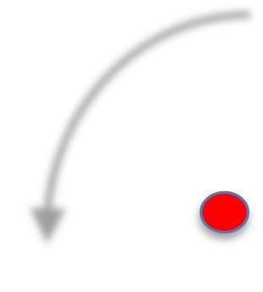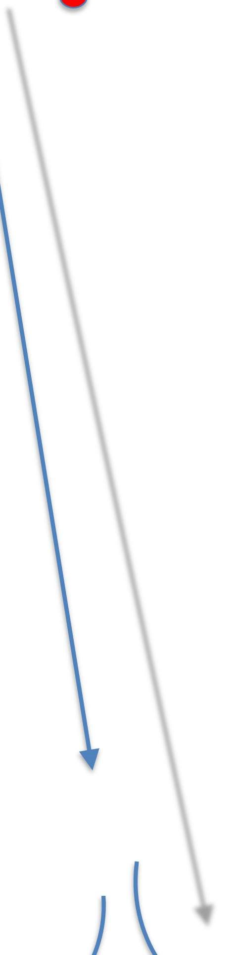

START LINE FINISH LINE

