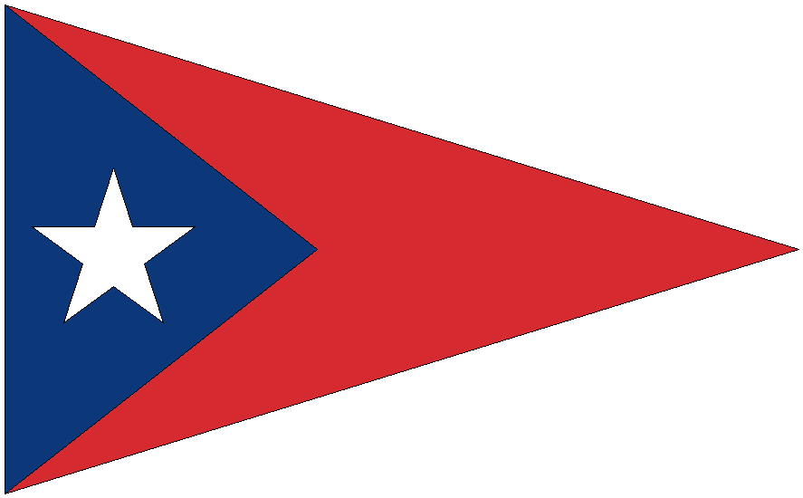
Bright Light Series & Sun Down Series for Juniors
Sailing Instructions

Bright Light Series Wednesdays: July 1, 8, 15, 2026 6:30 pm Warning Signal
Sun Down Series Wednesdays: July 22, 29, Aug 12, 2026 6:30 pm Warning Signal

- RULES
This series of races will be governed by the Racing Rules of Sailing 2025- 2028.
- NOTICES TO COMPETITORS AND CHANGES TO SAILING INSTRUCTIONS
Notices to competitors and changes to Sailing Instructions will be given verbally before the Warning Signal for each day.
- SIGNALS MADE ASHORE
The Blue and white checkered flag will be flown from the flagpole to Abandon Race days due to weather.
- SAFETY
4.1 RRS 40 applies - all competitors shall wear a USCG approved PFD during all time on the water.
4.2 All competitors shall sail by the Race Committee Signal boat on starboard tack to verbally check In with their sail number and class boat before the Warning Signal for the first race of every day.
- SCHEDULE FOR EVERY RACE DAY
Check In at Race Committee Signal boat
6:30 pm First Warning, subsequent races to follow with a maximum of 5 races per day
Class starts will be given orally on the water
- COURSES
Courses will be announced orally on the water before each Warning Signal. (See Course Diagrams)
- ROUNDING MARKS
Rounding Marks will be red hippity hops.
- THE START/FINISH
8.1 Races will be started using Appendix U the Sound Signal System.
8.2 The Start/Finish line is the same and will be from a staff with an orange flag on the race committee signal boat at the starboard end of the line to a red ball on the course side of the port end of the line.
- TIME LIMIT
Boats not finishing within 10 minutes of the first boat to finish in a class will be scored one more place than the number of finishes in that race. (This changes A5.)
- PROTESTS AND REQUESTS FOR REDRESS
The Race Committee shall be informed as soon as possible after a race by any boat that intends to protest another boat for an incident in that race. This changes RRS 61.1 (a). Hearing request forms for either a Protest or a Request for Redress will be available from the Race Committee after the Race Committee Signal boat docks, and must be filled out and handed to the Race Committee within 30 minutes after the Race Committee Signal boat docks. 6/05/2026 MAD

COURSE DIAGRAMS
1
2

START/FINISH
TRIANGLE – WINDWARD - LEEWARD
START-1-2-3-1-3-FINISH

TRIANGLE
START-1-2-3-FINISH

WINDWARD - LEEWARD
START-1-2-FINISH

1
2
3

START/FINISH
1
3
2

START/FINISH

