

Sailing Instructions E-Scow NYS Championship Regatta

Chautauqua Lake Yacht Club
Lakewood, NY

The notation ‘[DP]’ in a rule means at the discretion of the protest committee, the penalty for breaking this rule may be more or less than a single disqualification.

RULES

The regatta will be governed by the rules as defined in The Racing Rules of Sailing and the scantling rules of the National Class E Scow Association, and NCESA by-laws Articles VI and VIII, parts 4 and 5. Article VIII, Section 2 will not be in effect. Crew and or number of crew can change from race to race.

Flotation panels as described in Scantling IV (6) are to be used while racing. This change is invoked as permitted by Scantling II(F)(2)(d).

Rule 44.1 is changed so that the Two-turns Penalty is replaced by the One-turn Penalty.

All races will be scored. This changes to Appendix A2.

Appendix T applies as modified in SI 15.

CHANGES TO SAILING INSTRUCTIONS
Any change to the sailing instructions will be posted no later than 0800 on the day it takes effect, except that any change in the schedule of races will be posted by 2000 on the day before it takes effect.

NOTICE TO COMPETITORS

Notices to competitors will be posted on the official noticeboard located on the between the Race room and ladies locker room

Notices to competitors will also be posted on the event website page - NYS Championship Regatta (the Clubspot.com) under the Notice Board.

SIGNALS MADE ASHORE

Signals made ashore will be displayed by the race committee signal vessel when moored at the CLYC Dock and/or on the CLYC flagpole.

When code flag “AP” is displayed ashore, ‘1 minute’ is replaced with ‘not less than 45 minutes’
in the Race Signals AP.

Approximately one hour prior to the scheduled warning signal of the first race of the day, the race committee will fire a gun or make another sound signal.

COMPETITORS’ BRIEFING MEETING AND SCHEDULE OF RACES

The competitors’ briefing will be at approximately 1000, Saturday.

Six races are scheduled, of which one must be completed to constitute a regatta.

The Warning Signal for the first race, will be at 11:00am. Except when races are sailed back-to-back, the approximate time of the warning signal for subsequent races will be posted and/or announced on the competitors’ radio channel (VHF 73). For Sunday, the Warning Signal for the first race will be 10:00am.

No warning signal will be made after 2:00pm on Sunday, May 18th.

CLASS FLAG
The class flag will be the letter “E” on a white field.

RACING AREA
The racing area will be the navigable waters of the Southern Basin of Chautauqua Lake

THE COURSES

All courses will be Windward-Leeward courses (WA). All windward marks will have an offset mark. Races may finish downwind. Leeward gates will be used.

No later than the warning signal, the race committee signal boat will display the number of windward legs to be sailed.

When there is a gate, boats shall sail between the gate marks from the direction of the previous mark and round either gate mark. If only one mark of the gate is present, it should be rounded, leaving it to port.

Courses may be shorter than the minimums required in class.

MARKS

All marks will be orange balls, the offset mark will be an orange ball and Start/Finish will be a yellow ball.

After the start, minor adjustments in a mark’s location will not be signaled. This changes to RRS 33.

THE START

Races will be started by using RRS 26.

The starting line will be:

Between a staff displaying an orange flag on the race committee signal vessel and a mark.

Between two staff displaying orange flags on two race committee vessels. Signals will be made from the race committee signal vessel at or near the starboard end of the line.

A boat starting later than four minutes after her starting signal will be scored Did Not Start (DNS) without hearing. This changes RRS A4 and A5.

If RRS 30.2, 30.3 or 30.4 is used, flag Z, U or Black will be displayed alone as the Preparatory Signal. This changes Race Signals.

Following the starting signal, any boats identified as OCS by RaceSense will display “OCS” on the unit.

Following the display of Code Flag “X”, every effort will be made, as quickly and clearly as possible, to hail by VHF radio or otherwise a complete list of boats identified on the course side at the start or needing to comply with RRS 30.1. A boat’s actions after the start will not change this list (your number may be called, even if you are already clear). This changes to RRS 41. Such announcements are a courtesy and failure by the RC to make the announcement, or of boats to hear and/or understand it, shall not constitute grounds for redress. This changes RRS 62.1(a).

CHANGE OF THE NEXT LEG OF THE COURSE

To change the next leg of the course, the race committee will either move the original mark (or the finishing line) to a new position, or the RC will lay a new mark and remove the original mark as soon as practicable.

The RC may adjust gate marks without further signaling to maintain the appropriate course configuration.

The course changes to less than 5 degrees and/or 10% leg length, made before any boat begins the leg, may not be signaled. This adds to RRS 33.

THE FINISH

The finish line will be between:

A staff displaying a orange flag on a race committee vessel and the course side of a nearby yellow tetrahedron mark or

A staff displaying a orange flag on a race committee vessel and a staff displaying a orange flag on another race committee vessel.

Flag “A” displayed on the race committee vessel with no sound while boats are finishing means
‘No more racing today.’

Flag “H” displayed on the race committee vessel with no sound while boats are finishing means
‘Racing will continue after a break either on shore.’

When neither Flag “A” nor Flag “H” is flying on the race committee vessel while boats are finishing, another race will follow.

PENALTIES
RRS 44.1 is changed so that the Two-Turns Penalty is replaced by the One-Turn Penalty.

TIME LIMIT

The time limit will be 90 minutes for any race.

Boats still racing 20 minutes after the first boat sails the course and finishes will be scored TLE (Time Limit Expired), the position of the last boat that complies with RRS 28 to finish plus two without hearing. This changes to RRS 35, A4.2, and A10.

On Sunday, the last day of racing, no races will start after 1400h.

PROTEST AND REQUESTS FOR REDRESS

A boat intending to protest or request redress about an incident that occurs in the racing area is requested to notify the race committee finish vessel on station of her intention, including the sail number of any boat(s) being protested.

Hearing requests shall be filed using the link on the notice board. QR Codes will be posted at the cranes for quick access to the online form.

The protest time limit is one hour after the last boat finishes the last race of the day, or one hour after no more racing today is signaled, whichever is later.

Notices will be posted on the online notice board no later than 30 minutes after the protest time limit to inform competitors of hearings in which they are parties. Hearings will be held at a location at Regatta Headquarters.

Notices of protests by the race committee, technical committee or protest committee will be posted to the online notice board within the protest time limit to inform boats under RRS 61.1(b).

Appendix T - Arbitration applies. T1(b) Is changed to, Post-Race Penalty is a 30% Scoring Penalty calculated as stated in rule 44.3(c) or 50% of the places between the boat’s finishing position and the number of entries, whichever is less. However, rule 44.1(a) applies. This changes RRS T1(b).

SCORING
The Low Point System in Appendix A of the RRS will apply, except that RRS A2 is changed so that each boat's total score will be the sum of her scores for all races.

SAFETY

Boats are required to always sail with masthead flotation panels while afloat. Failure to do so will result in being scored DSQ without hearing. This changes to RRS 63.1.

A boat that retires shall notify the race committee as soon as possible.

EQUIPMENT & MEASUREMENT CHECKS
A boat or equipment may be inspected at any time in compliance with the class rules, notice of race and sailing instructions.

MEDIA RIGHTS
Competitors give absolute rights and permission for video footage or photographs of themselves, or their boat generated during the event to be published in any media for press, editorial or advertising purposes.

RADIO COMMUNICATION

Except in an emergency, a boat shall neither make radio transmissions while racing nor receive radio communications not freely available to all boats or medically necessary. This restriction also applies to mobile telephones.

The Competitors’ channel is VHF 73.

CODE OF CONDUCT
[DP] Competitors and support persons shall comply with any reasonable request from a race official.

DISCLAIMER OF LIABILITY
Competitors participate in the regatta entirely at their own risk. See RRS 3, Decision to Race. The organizing authority will not accept any liability for material damage or personal injury, or death sustained in conjunction with or prior to, during, or after the regatta.

Appendix #1 Course Supplement

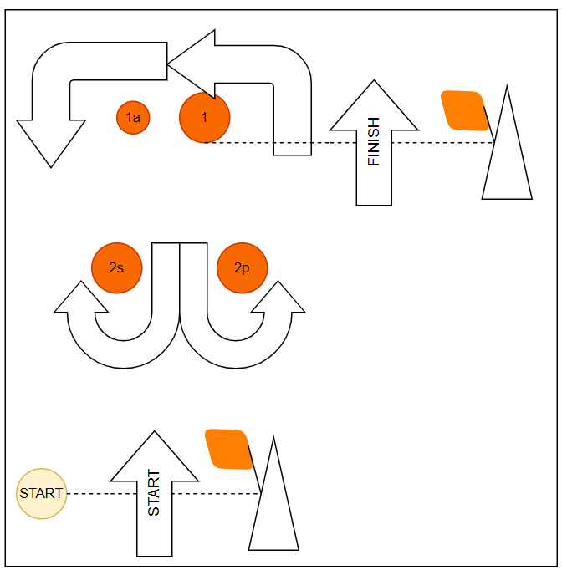
Course WA - Windward/Leeward with Offset Mark, Windward Finish
Signal | Mark Rounding Order
WA2 | Start - 1 - 1a - 2s/2p - Finish
WA3 | Start - 1 - 1a - 2s/2p - 1 - 1a - 2s/2p - Finish
WA4 | Start - 1 - 1a - 2s/2p - 1 - 1a - 2s/2p - 1 - 1a - 2s/2p - Finish
WA5 | Start - 1 - 1a - 2s/2p - 1 - 1a - 2s/2p - 1 - 1a - 2s/2p - 1 - 1a - 2s/2p - Finish
Course LA - Windward/Leeward with Offset Mark, Leeward Finish
Signal | Mark Rounding Order
LA2 | Start - 1 - 1a - 2s/2p 1 - 1a - Finish
LA3 | Start - 1 - 1a - 2s/2p - 1 - 1a - 2s/2p - 1 - 1a- Finish
LA4 | Start - 1 - 1a - 2s/2p - 1 - 1a - 2s/2p - 1 - 1a - 2s/2p - 1 - 1a - Finish
LA5 | Start - 1 - 1a - 2s/2p - 1 - 1a - 2s/2p - 1 - 1a - 2s/2p - 1 - 1a - 2s/2p - 1 - 1a – Finish (yellow tetrahedron mark)
