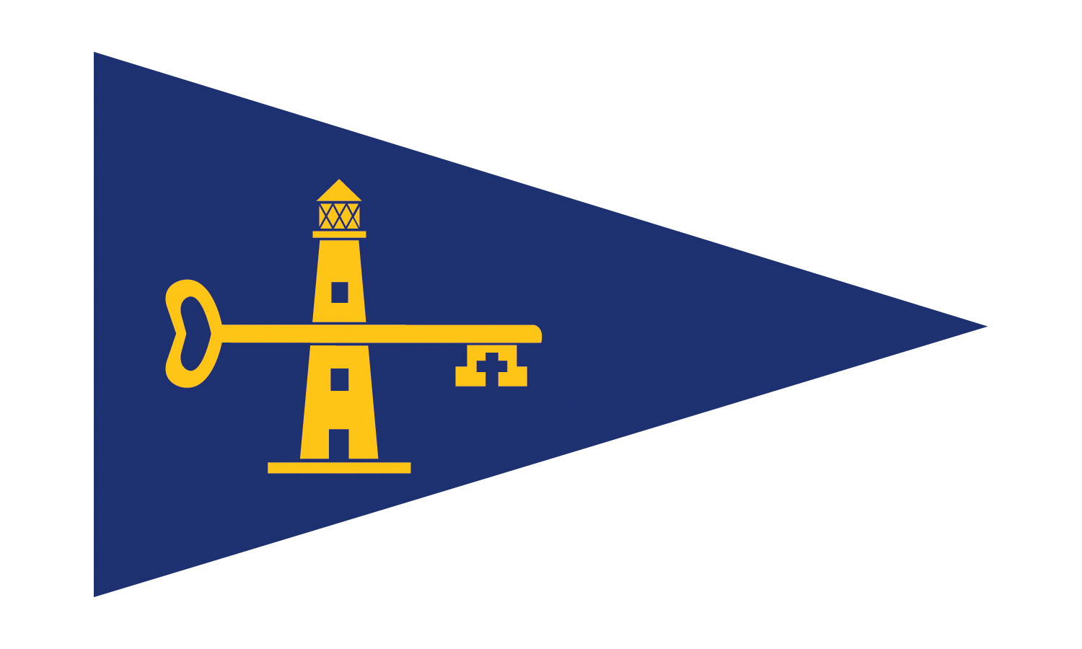
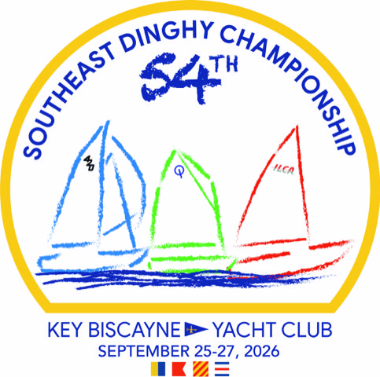

NOTICE OF RACE

54th Southeast Dinghy Championship
Classes: ILCA 4 & 6, Optimist RWB & Green Fleets
September 25 - 27, 2026

The Organizing Authority and Event Venue for the 54th Southeast Dinghy Championship (SEDC) is the Key Biscayne Yacht Club (KBYC), 180 Harbor Drive, Key Biscayne, FL 33149.

1.0 Rules
1.1 The Regatta will be governed by the rules as defined in “THE 2025-2028 RACING RULES OF SAILING (RRS)”.
1.2 Appendix P, Special Procedures for Rule 42, will apply.
The title of RRS P2.2, “Second Penalty” is changed to “Second and Subsequent Penalties”. When a boat is penalized a second time during the regatta, she shall promptly retire, unless her penalty was signaled after she finishes, in which case she shall promptly notify the race committee at the finish line that she is retiring. RRS P2.3 is deleted.
1.3 A Competitor shall neither make nor receive radio, telephone or electronic transmissions that are not available to all competitors while racing.
1.4 All competitors shall wear a properly secured US Coast Guard approved personal flotation device (“PFD”) at all times while afloat regardless of their MNA (Member National Authority) affiliation. In order for a life jacket to meet US Coast Guard requirements, it must be worn as directed by the manufacturer’s instructions free of any rips or tears and have a label that is able to be read. The PFD shall not be an inflatable type life jacket. The PFD may be removed temporarily so that clothing may be changed, added or removed. Sailors must show their USCG approved PFD at check-out.
2.0 Eligibility and Entry
2.1 ILCA (4 & 6) and Optimist RWB & Green Fleet competitors may enter by completing the registration and paying the required fees, with a maximum number of boats in each class as follows:
Class Registration Cap
Green Fleet 80
RWB Fleet 150
ILCA 4 50
ILCA 6 50

2.2 Competitors and coaches shall complete the Waiver and Release of Liability and Medical Release and Photographic Consent forms as part of the event registration.
2.3 Registration and all documents to be found on the Clubspot regatta website: https://theclubspot.com/regatta/Ga2mujAmu1
2.4 A Sunday only ILCA 4 & 6 class may be offered if, and only if, a SAISA regatta is scheduled on the same dates. An amendment to the NOR may be posted if this occurs.
2.4.1 Only sailors participating in a SAISA regatta would be eligible to register for the “Sunday only” classes.
3.0 Registration
3.1 Competitors and Coaches shall register on-line via Clubspot registration https://theclubspot.com/register/regatta/Ga2mujAmu1/class before 23h59 Friday, September 18th, 2026. Registrations not fully paid by this time may be rejected.
3.2 The early entry fee is $195 for applications received by Monday, September 7th.
3.3 A late fee of $40 ($235 total entry fee) will apply to entries after Monday, September 7th through Friday, September 18th.
3.3.1 The entry fee for classes “ILCA 4 “Sunday only” and ILCA 6 “Sunday only” will be $100 if applicable.
3.4 Entries will only be accepted after Friday, September 18th at the discretion of the Organizing Authority with the payment of the late entry fee ($235 per entry).
3.5 Registration will open at 13h00 on Monday, July 6th, 2026. We will maintain a waitlist and we expect more spots will become available when we get closer to the regatta.
3.6 Refund of Entry Fees: if a competitor withdraws from Southeast Dinghy Championship, the entry fee will be refunded as follows:
- Up to Friday, September 11th: the entry fee paid will be refunded through Clubspot less a $50 administration fee.
- After Friday, September 11th: no entry fee will be refunded.

3.7 The entry fee for each Coach is $60 (breakfast/lunch and after sailing snacks included). An additional $50 “Flag Deposit” will be collected at the regatta and will be refunded if the flag is returned on Sunday, September 27th. The Coach Flag shall be prominently displayed on the coach boat.

3.8 Spectator boats will be required to register at KBYC (no fee will apply) and pay a refundable $50 flag deposit provided the flag is returned on Sunday, September 27th. Spectators are not permitted to have contact with Competitors or to enter the race course. The Spectator Flag shall be prominently displayed on the spectator boat. Spectators shall be respectful of the course area. Vessels not displaying flags will be discouraged from approaching the course area by US Coast Guard and/or safety boats.

4.0 Event Format
4.1 If any fleet has a large number of entries, the Organizing Authority may also decide to divide that fleet.
4.2 If applicable on Sunday September 27th, should a Sunday only ILCA 4 & 6 class be included, it is anticipated that the SEDC ILCA 4 and the ILCA 4 Sunday only classes will race together on the same starts and race courses and likewise for the SEDC ILCA 6 and ILCA 6 Sunday only classes. The final decision to organize the starts and courses for each class will remain with the Organizing Authority. Despite this there will be no overlap or merging of results e.g. a Sunday only sailor who scores all 1st places on Sunday will not be scored in the SEDC class overall results, their results will only show in the Sunday only class.
5.0 Schedule of Events
5.1 Dates:
Friday, September 25th, 2026
Official Arrival Day for All classes
1600-1830 Competitor & Coach Check In (KBYC Patio)
Saturday, September 26th, 2026
0730-0830 Competitor & Coach Check In (KBYC Patio)
0800-1000 Competitor & Coach Continental Breakfast (KBYC Patio)
0830 Coaches Meeting
0900 Skippers Meeting
1100 First Warning RWB/ILCAs (Races to follow)
1130 First Warning Green Fleet (Races to follow)
After Sailing Snacks (Poolside)
Sunday, September 27th, 2026
0800-0900 Competitor & Coach Continental Breakfast (KBYC Patio)
0830 Coaches Meeting
1030 First Warning RWB/ILCAs (Races to follow)
1100 First Warning Green Fleet (Races to follow)
After Sailing Snacks (Poolside)
Closing Ceremony and Awards to follow at KBYC
5.2 No more than five races per fleet will be scheduled for each day.
5.3 No warning signal will be made after 1430 on Sunday, September 27th.
5.4 A minimum of one (1) race shall constitute a regatta. A maximum of eight (8) races, in total, are scheduled for the entire regatta.
6.0 Measurement
6.1 Equipment inspection may be required at this regatta. Each boat shall comply with the equipment measurement rules of the Class and may be inspected at any time during the Regatta at the discretion of the Protest Committee or the Organizing Authority.
6.2 Competitors boats may be required to display advertising chosen and supplied by the Organizing Authority.
7.0 Sailing Instructions
7.1 The Sailing Instructions will be available online on or before check-in on the regatta website.
8.0 Venue
8.1 The racing area will be located in Biscayne Bay, FL.

9.0 Courses
9.1 Courses will be trapezoid, modified triangle and/or windward/leeward.
10.0 Scoring
10.1 The Low Point Scoring System, Appendix A2, will be used, except as modified below.
10.2 When five (5) or more races have been completed, a boat series score will be the total of her race scores excluding her worst score.
10.3 There will be Class Scoring ILCA 4 & 6, ILCA 4 Sunday only, ILCA 6 Sunday only (youth up to age 19) if applicable, and ILCA 6 (adult over 19), RWB & Green Fleet for Trophy awards.
11.0 Prizes
11.1 In the Optimist Fleet awards will be given to the top three finishers in the Red, Blue, and White Fleets and top five overall and top overall girl. All Green Fleet sailors will receive an entry gift. The top five boats and top overall girl in Green Fleet will receive an award.
11.2 Awards will be given to the top three finishers of ILCA 4 & 6. Top overall girl for ILCA 4 & 6 will be given. Competitors aged 19 and over will not be eligible for prizes.
11.3 The Larimore, Corinthian & Stickney Perpetual Trophies will be awarded to sailors as follows:
The Larimore Trophy
The Larimore Trophy is awarded to the first-place competitor in the Optimist RWB Fleet.
The Corinthian Award
The Corinthian Award, donated by past Commodore Hortensia Hacker and Family, honors the Youth Sailor selected by his or her peers at the KBYC Southeast Dinghy Championship in recognition of the highest level of sportsmanship, fairness, and concern for others.
The Stickney Trophy
The Stickney Trophy is awarded to the first placed Optimist RWB dinghy sailor who is a member of the Key Biscayne Yacht Club, a member of the Key Biscayne Yacht Club Sailing Team, being coached by Key Biscayne Yacht Club Coaches and is participating in the Southeast Dinghy Championship under the Key Biscayne Yacht Club burgee.
11.4 The ILCA 4 Sunday only and ILCA 6 Sunday only classes, if included, will not be eligible for the above SEDC Championship prizes. Awards for Sunday only sailors will be made at the discretion of the Organizing Authority.
12.0 Support Boats
12.1 Race Committee boats will fly a Race Committee (“RC”) flag or an Official (“O”) flag.
Coach boats shall fly a blue, numbered flag. Boats flying a blue, numbered flag will be permitted in the coaching area.
Safety Boats will fly a yellow or orange flag with an “S” or an “RC”.
Spectator Boats will fly a red or a blue, numbered flag. Spectator boats are not permitted in the coaching area. Boats without the above-mentioned flags will be diverted from the racing area.
12.2 All support vessels should be equipped with a functioning engine safety cut-switch (kill switch) which should remain attached to the support person at all times while the engine is running. Failure to comply may be misconduct and/or result in expulsion from the event.
12.3 Private team (non-club) coaching is permitted, provided that such private coaches:
- Hold a current US Sailing Small Boat Level 1 (or higher) Instructor Certification, or the equivalent issued by another World Sailing Member National Authority.
- Have completed current SafeSport Training through the U.S. Center for SafeSport.
- Are individual or family members of US Sailing, in good standing.
- Are not otherwise ineligible to coach under the law, regulation, or the policies and rules of US Sailing or its affiliated organizations.

12.4 Additional Insurance Requirement:

All coaches must hold a valid insurance certificate if coaching privately or being employed privately or by an organization that does not carry appropriate insurance coverage. A copy of this certificate must be sent by email to the OA no later than Friday September 18th, 2026.

12.5 Other Requirements:
- All coaches must wear a USCG-certified personal flotation device (PFD) while on the water regardless of their MNA affiliation.
- All coach boats must have a kill switch in proper working order when on the water, and it must be deployed whenever the engine is running.
- All coaches must comply with the Sailing Instructions as published for the event.

13.0 Administrative
13.1 Competitors are welcome to arrive at Key Biscayne Yacht Club on Friday, September 25th. Competitors wishing to arrive earlier than Friday, September 25th, or depart later than Sunday, September 27th, will need to make arrangements with the Regatta Chair. Participants are not permitted to launch or practice at KBYC prior to Friday, September 25th. Competitors arriving when KBYC is closed, on Thursday, September 24th, or after KBYC business hours, may park boats at their assigned locations but must coordinate with the Regatta Chair to park trailers.
14.0 Disclaimer of Liability
14.1 Competitors participate in the regatta entirely at their own risk.
See RRS Rule 4, Decision to Race.
The Organizing Authority will not accept any liability for material damage, or personal injury, or death (including but not limited to, illness related to COVID-19) sustained in conjunction with, prior to, during, or after the regatta.
15.0 Rights to use Names and Likeness
15.1 Competitors automatically grant to the Organizing Authority without payment the right in perpetuity to make, use and show any motion pictures, still pictures and live, taped or filmed television of or relating to the event.

16.0 Further Information
Key Biscayne Yacht Club
180 Harbor Drive, Key Biscayne, FL 33149
https://www.kbyc.org/Sailing/Youth_Sailing/Youth_SE_Dinghy_Championship
Regatta Chairs: Claire Mueller & Tom McCormick
email: sedc@kbyc.org

