
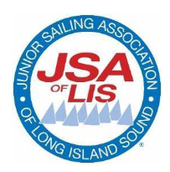
Douglaston Optimist and O’Pen BIC Regatta
Douglaston Junior Yacht Squadron
The Douglaston Club: 600 West Drive Douglaston, NY 11363
Thursday July 23RD, 2026
NOTICE OF RACE
AMENDMENT # 1

Section 2 and Section 4 of the Notice of Race has been amended as noted in red:

