Release Rev 06/29/2026

WYA C Scow Championship Regatta
Organizing Authority – Wisconsin Yachting Association
Host – Nagawicka Lake Yacht Club, WI
Friday, July 31st 2026 – Sunday, August 2nd 2026

Preamble – The notation ‘[NP]’ in a rule means that a boat may not protest another boat for breaking that rule and for
which the Jury may refuse to hold a hearing. This changes RRS 60.1(a) and 63.1 as stated below. The notation ‘[DP]’ in a
rule means that the penalty for breaking this rule may, at the discretion of the Jury, be less than disqualification.

NOTICE OF RACE

- Rules
  - The event is governed by the rules as defined in The Racing Rules of Sailing.
  - In addition to other rules changed in this document, the following racing rules are changed:
    - RRS 29.1 is changed as follows: ‘…with one sound. Additionally, as soon as practicable, the Race Committee will hail via the competitor VHF channel the list of boats identified that shall comply with RRS 30.1 and/or RRS 30.2. The flag…”
    - RRS 30.3 and 30.4 add: “Additionally, the Race Committee may hail via the competitor VHF channel the list of boats identified as breaking RRS 30.3 or 30.4.”
    - RRS 33 adds: “(d) Course bearing changes less than 5 degrees made before any boat begins the leg maybe made without signaling.
    - RRS 35 adds: If a finishing window is described in the NOR boats not finishing within the finishing window be scored by the Race Committee as TLE. TLE will be scored two points more than the points for the last boat that sailed the course and finished prior to the finishing window closing. TLE for this regattas 20 minutes after the first boat finishes.
    - RRS 41 adds: “(e) help to recover from the water and return on board a crew member, provided the return on board is at the approximate location of the recovery.”
    - RRS 44.1 and 44.2 is changed: All instances of “Two-Turns Penalty” are replaced with “One-Turn Penalty.”
    - RRS 60.1 adds: (d) not protest another boat or request redress for a rule with the notation [NP].
    - RRS 63.1 adds after withdrawn: “or is based on a rule with the notation [NP].
    - RRS A5 adds - A boat that is scored TLE by the Race committee shall be scored points for the finishing place two more than the number of boats that finished.
    - RRS A10 adds: TLE Finishing Window Time Limit Expired.
- Sailing Instructions
- The Sailing Instructions will be available at https://sailnlyc.com/regatta/sUyY5mHNdE
- Communication
  - The official notice board is located at https://sailnlyc.com/regatta/sUyY5mHNdE/#notice-board

  - An unofficial physical notice board will be located inside the NLYC Clubhouse.
  - In addition to official notice board posts, text messages and/or emails may be sent to the phone number and/or email address listed during entry. If such a message is sent to an individual under the age of 18,the communication will be simultaneously sent to the adult’s information on file. Failure to receive these messages shall not be grounds for redress.
  - All Boats shall carry a VHF radio capable of communicating on VHF channels 16, 68, 69, 72, and 74.
  - While Racing, except in an emergency, a boat or support person shall not make voice or data transmissions and shall not receive voice or data communication that is not available to all boats.
- Eligibility and Entry
  - The event is open to boats of the C Scow Class.
  - Eligible boats may enter the event by registering online at Https://sailnlyc.com/register/regatta/sUyY5mHNdE/class

  - To be considered an entry in the event, a boat shall complete all registration requirements, and pay all fees, and complete the on-site check in process the day of the event.
  - Late entries will be accepted with payment of all required late fees.
  - The registered helmsman must skipper the yacht.
  - In the event co-helmsmen are registered, both must be on board for each race unless the Principal Race Officer is notified before the race, and he agrees to valid reasons for doing so.
- Fees
  - Entry fees are as follows:

Class | Entry Fee until July 21th at Midnight | Entry Fee after July 21^{th,} 2026 and until onsite registration | Entry Fee onsite
C Scow | $ 85.00 | $130 | $ 130

  - Other fees (Fees include 2 lunches for both Saturday and Sunday.)
    - Meals will be available for purchase through the Club spot system at $12 per meal in advance or $15 on site.
    - Friday Appetizer Party 5:30PM. Drinks at bar will be available for purchases. Appetizers will be provided by host club.
    - Light Snacks will be provided for breakfast in the morning.
    - Saturday evening party $40 dinner, live music, dancing
    - Other official WYA merchandise will be available at club and clubspot.com

- Crew Limitations
  - The following crew limitations apply:
  - There will be no boats provided by the host club nor the WYA for crew changes out in the racing area.
- Advertising
  - The organizing authority does not anticipate any advertising. NLYC has several sponsors for the regatta. Please keep these companies in mind for future purchases as they are directly support our sport. Thank you!
- Schedule
  - All registration online and check in will be Thursday, July 30th from 1600-2000 and Friday, Jully 31st from 0800 – 1230. Please make an effort to launch Thursday to prevent influx of boats Friday Morning.
  - Boats and competitors are permitted to arrive at the Nagawicka Lake Yacht Club beginning at 1600 on Thursday, July 30th. Upon arrival and throughout the event, follow all traffic signs and follow any reasonable request from the logistics team, organizing authority, or race management team.
  - Dates of racing:
Class | Racing Begins | Racing Ends
C Scow | Friday, July 31st 2026 | Sunday August 2rd 2026

  - Number of races:
Class | Scheduled Number of Races | Maximum Races in a Day
C Scow | 5 | 3

  - [NP] Failure for a race to meet the target time shall not be grounds for a request for redress.

  - The competitors briefing will be at the Clubhouse and:
Class | VHF Channel | Date/Time
C Scow | 69 | 12:00 pm Friday July 31st

  - 8.7 Race Schedule, unless conditions warrant changes
(Bylaws demand all race times pre posted)
RACE | Time | Date
1 | 13:30 | 1:30 Friday July 31st
2 | Immediately Following | 1:30 Friday July 31st
3 | 10:00 | Saturday, August 1st
4 | 14:00 | Saturday, August 1st
5 | 10:00 | Sunday, August 2nd

  - The Sailing Instructions will define the process for the publication of the subsequent race schedule. If one or more races have been sailed, the latest warning signal on Sunday will be 1:00 PM. In any case, no warning signal will be made after 3:00 P.M. on Sunday. (Bylaws demand all race times pre posted)
- Equipment Inspection
  - There will be no equipment inspection for this regatta.
- Venue
  - The event will take place at the Nagawicka Lake Yacht Club, address 1131 Mariner Dr, Hartland, WI 53029. The venue is shown in NOR Addendum A – Venue.
- Courses
  - The courses will be windward/leeward courses.
- Penalty System
  - Appendix T applies as changed below:
    - RRS T1(b) is changed as follows: “A Post-Race Penalty is a 30% Scoring Penalty or 50% of the points between a boat’s finishing position and the number of entries, whichever is less, calculated as stated in rule 44.3(c). However, Rule 44.1(a) applies.
  - Appendix V2 applies as changed below:
    - RRS V2(b) is changed as follows: “A Post-Race Penalty is a 30% Scoring Penalty or 50% of the points between a boat’s finishing position and the number of entries, whichever is less, calculated as stated in rule 44.3(c). However, Rule 44.1(a) applies.
- RRS Appendix A1 and A2
  - One race is required to constitute a series:
  - A boat’s series score will be the total of her race scores.
- Support Person Vessels
  - No accommodation will be made for launching, retrieving, or storing support person vessels.
- Parking
  - [DP] Boat trailers shall be kept at the site announced after launching
  - [DP] Boats will be moored in Southwest shore of Nagawicka (See map) . Plan for 10-20’ of water depth and ensure proper anchors. We suggest Danforth anchor.
  - [DP] Dry Sailing at NLYC will not be permitted.. Nagawicka C scows with pre designated lagoon spots will be permitted to keep boats on lifts during duration of regatta.
- Risk Statement
  - Sailing is by its nature an unpredictable sport and therefore inherently involves an element of risk. Competitors and support persons participate in the event entirely at their own risk. RRS 3 states: ‘The responsibility for a boat’s decision to participate in a race or continue racing is hers alone.” By taking part in the event, each competitor agrees and acknowledges that:
    - They are aware of the inherent element of risk involved in the sport and accept responsibility for the exposure of themselves, their crew and their boat to such inherent risk whilst taking part in the event. Inherent in the sport of sailing is the risk of permanent catastrophic injury or death by drowning, trauma, hypothermia, or other causes.
    - They are responsible for the safety of themselves, their crew, their boat and their other property while afloat or ashore;
    - They accept responsibility for any injury, damage or loss to the extent caused by their own actions or omissions;
    - By participating in any race, they are satisfied that their boat is in good order, complies with the class rules, is equipped to sail in the event and they are fit to participate.
    - The provision of a race management team, patrol boats, umpires and other officials and volunteers by the organizer does not relieve them of their own responsibilities.
    - The provision of patrol boat cover is limited to such assistance, particularly in extreme weather conditions, as can be practically provided in the circumstances.
    - It is their responsibility to familiarize themselves with any risks specific to this venue or this event drawn to their attention in any rules and information produced for that venue or event and to attend any safety briefing held for the event.
- Insurance
  - [NP] [DP] Each participating boat shall be insured with adequate valid third-party liability insurance.
- Prizes
  - Prizes will be given as follows:
  - The top 10 finishers.
  - WYA Perpetual Trophies will be awarded.
  - Top Female Skipper
  - Top Youth Sailor (Below 25 years)
- Amendments to the Notice of Race
  - This NOR may be changed.
  - Changes to the NOR will be posted to https://sailnlyc.com/regatta/sUyY5mHNdE/#notice-board

- Social
  - Following racing completion Friday August 1nd light appetizers will be available and beverages will be available for purchase. Following racing on Saturday, August 2nd, all sailors and families are invited to attend the dinner, music and dancing. Music will be performed by Retrosonic.
- Further information
  - For further information, contact Regatta Chair Mark Price at mark.price.46@gmail.com or 414-254-9346Addendum A – Venue(next page)Lauch Map
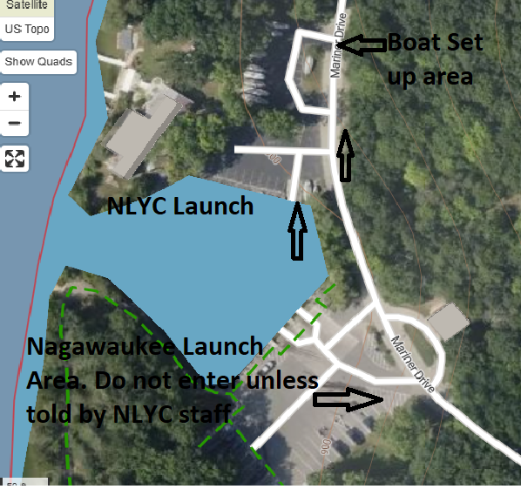
Mooring Area- 