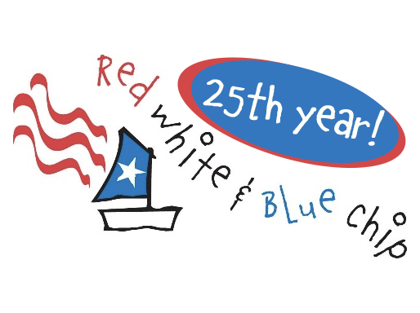
Notice of Race

RED, WHITE, AND BLUE CHIP REGATTA
25th ANNUAL OPTIMIST INVITATIONAL CHAMPIONSHIP
AUGUST 2-4, 2026
LA BELLE YACHT CLUB

Race Venue is located at: N59W38465 Kohl Lane, Oconomowoc WI 53066

______________________________________________________________________________

1. Eligibility: Competitors must be invited to participate in the Red White & Blue Chip Regatta based on regatta finishes at designated qualifying regattas or by receiving a Club Invitation (on criteria they determine).
2. Fleets (Ages as of August 2, 2026):
• White Fleet (10 years and under)
• Blue Fleet (11 – 12 years)
• Red Fleet (13 – 16 years)
3. Schedule of Events
• Launching and Check-in: 4:00 – 7:00 pm Sunday and 7:30 – 8:30 am Monday. N59W38465 Kohl Lane, Oconomowoc WI 53066. Please note that this is a private residence and more details will follow about parking.
• Fun Race: 6:00 pm Sunday (weather permitting)
• Competitors’ and Parents’ Briefings: 9:00 am Monday, Regatta tent
• First Race Warning: 10:00 am Monday. See Sailing Instructions
• Mystery Sailor: Discussion with a special guest star after Monday’s sailing!
- Party (kids and adults): 5:30pm - 8:00pm Monday - Volleyball, Games, Egg Toss Competition, and Dinner at Stone Bank Community Park, W335N7065 Stone Bank Rd, Oconomowoc, WI. Party costs are included for registered sailors, and siblings and adults are invited for an additional $10 each. Includes live auction of the beautiful framed original commissioned Opti artwork for 2026.
- First Race Warning Tuesday: TBD after Monday sailing
4. Regatta Communications
- The official notice board will be located on the regatta website, with an unofficial board located at Regatta Headquarters.
- Sailing instructions and Protest Forms are available on the regatta website
5. Fees and Registration: $150 per sailor
• Registration fee includes racing, two lunches and snacks for sailors, sailor souvenir bag, regatta awards, party for sailors (includes dinner), and more!
• Note: while registering, please be sure to register and pay for the Monday night party for any siblings and adults who are attending the regatta, and for any t-shirts for your sailor or others. Lunches beyond those for the sailor may also be ordered as part of registration. Please note that many restaurants in downtown Oconomowoc are not open on Mondays.
• Given the close scheduling of qualifying regattas, no late fees will be charged to invited sailors. All sailors who have registered by midnight (central time) on Tuesday July 28 will have their name printed on the annual t-shirt, available at regatta HQ on Monday, August 4.
6. Supervision: Each sailor is required to have a parent or other designated adult in attendance who will indicate in writing that he/she is responsible for the sailor’s well-being at the regatta.
7. Communication: Any communication between sailors and parents/support persons or coaches while racing is strictly prohibited and may result in a penalty to the competitor. All electronic devices used for communication are prohibited while on the water (i.e., cell phones or radios).
8. Judges and Instructors: US Sailing Certified Race Committee and Jury members will be used. Sailing school instructors/coaches are not required to attend this regatta, but are welcome and encouraged to come! There is no charge for coach attendance, and lunches are also provided at no charge - but please register so we can expect you.
9. Awards:
• First Place Overall receives the Red White & Blue Chip Traveling trophy
• Top ten Overall finishers receive trophies
• Top three for each fleet (White, Blue, Red) receive trophies
• Race Winner prizes awarded for each completed race
• All participants will receive a regatta award for their overall finish
• The coveted traveling Sportsmanship trophy will be awarded to a participant showing exemplary conduct, such as fairness, respect for one's opponent, and graciousness in winning or losing.
10. Watching the Regatta:
• Spectator Boats: LYC will provide complimentary spectator boats. Regatta guests are encouraged to use LYC boats. While registering, please indicate how many spectators you will have each day.
• Coach Boats and Personal Spectator Boats: Public launch is available at the Oconomowoc City Beach Launch, 324 W Wisconsin Ave, Oconomowoc. Cost/day is $13.75 for motor boats and sailboats. This fee must be paid by credit card via the kiosk at the launch site, and covers launching and removing one boat in a calendar day. If boat is removed a different day, an additional $13.75 is due via the kiosk. No pier space will be available at the regatta site; you will need to bring a mooring buoy and line (anticipate up to 20' water depth) for all coach boats and any personal spectator boats that aren’t removed overnight. Taxi boats will be provided for moored boats, and we appreciate the assistance of coach boats for this as well.
11. Rules:
- The event is governed by the rules as defined in The Racing Rules of Sailing.
- Rule 60.4(a)(2) is changed as follows: ‘(2) if it alleges a breach of a rule of Part 2 or rule 31 and is from a boat that was not involved in, and did not see, the incident, or’
- The preamble to Part 4 of the Racing Rules of Sailing will be changed to require Personal Floatation Device use at all times while sailing. A U.S. Coast Guard-approved personal flotation device shall be worn, properly fastened, at all times while launching and sailing, except while temporarily adding or removing clothing.

12. Overnight Storage:
- Optis will launch at the regatta headquarters with no launch fees.
- Optis may be kept on the lawn at regatta headquarters
• Coach and spectator boats must be moored or pulled out at the end of each day.
• Boat trailers may be parked in the lot at Park Lawn School, 0.3 miles from the launch (see map)
• La Belle Yacht Club accepts no responsibility for equipment

CONTACT:

Diane Gallo
608-575-2268 (text or voice)
degallo393@icloud.com

